Getting Started with Speech to Text
Speech to Text in School - Where to find it. / How to set up the headset microphone. / Checking Sound. /Built in Tutorials "How to Train Your Computer to Better Understand You". / Using Speech to Text in School - Word Pad and Ivona Mini-Reader. Basic word commands.

  - Using Speech to Text in school
Selkirk High School Additional Needs Department
November 2014

How to set up the headset microphone
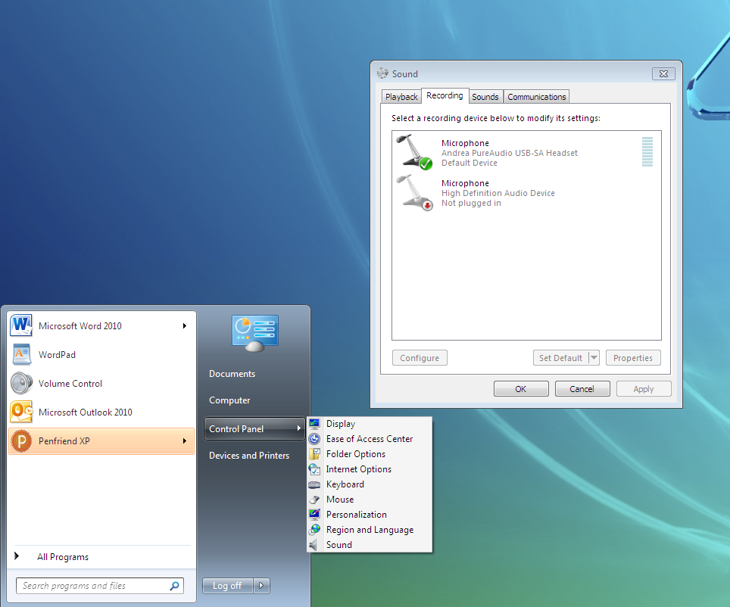
Plug in the headphone set before logging on to the computer.
Now log in.

Start/ Control Panel / Sound/ Recording

Make sure your headset is selected and press OK.

Checking sound
Start/ All Programmes/ Accessories/ Volume Control
Make sure the sliders at the top
Remember to check the screen volume is on too
USING SPEECH TO TEXT SOFTWARE IN SCHOOL
Plug in you headphones with microphone. Check the volume.
Start All Programmes/ Accessibility/Speech recognition
Click on Start Speech Recognition
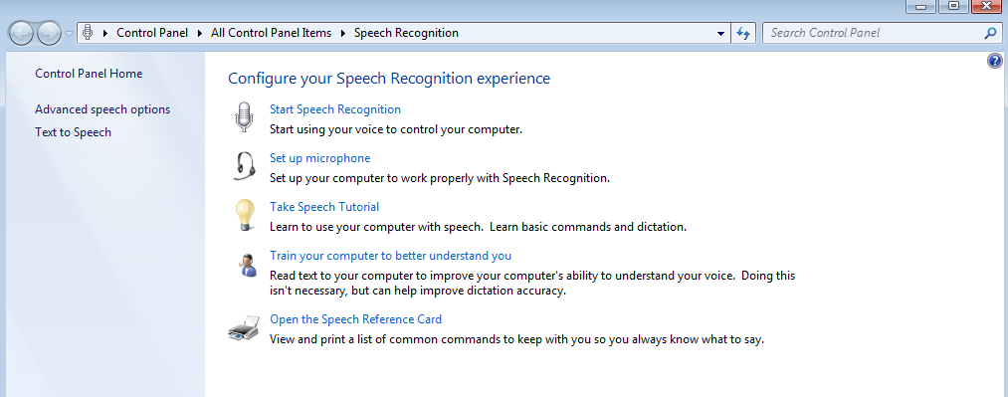
Choose your microphone

Position the microphone correctly

Adjust the volume.
Read the text in italics
“ Peter dictates to his computer. He prefers it to typing, and particularly prefers it to pen and paper.”

Click to disable or enable document review.

Choose voice activation.

Now work through
Speech Tutorial and Train Your Computer to better understand you

The Speech Reference Card has already been printed out for you

Reference sheet – see attached
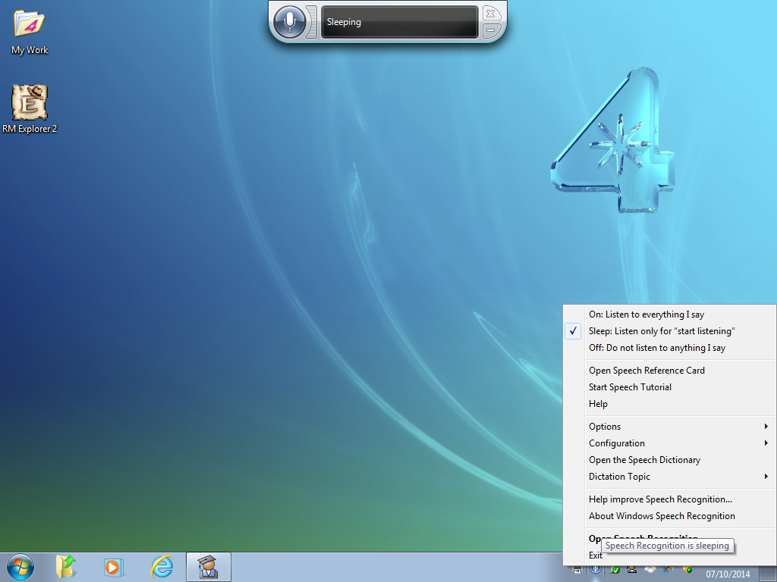
Speech to Text Software in Word
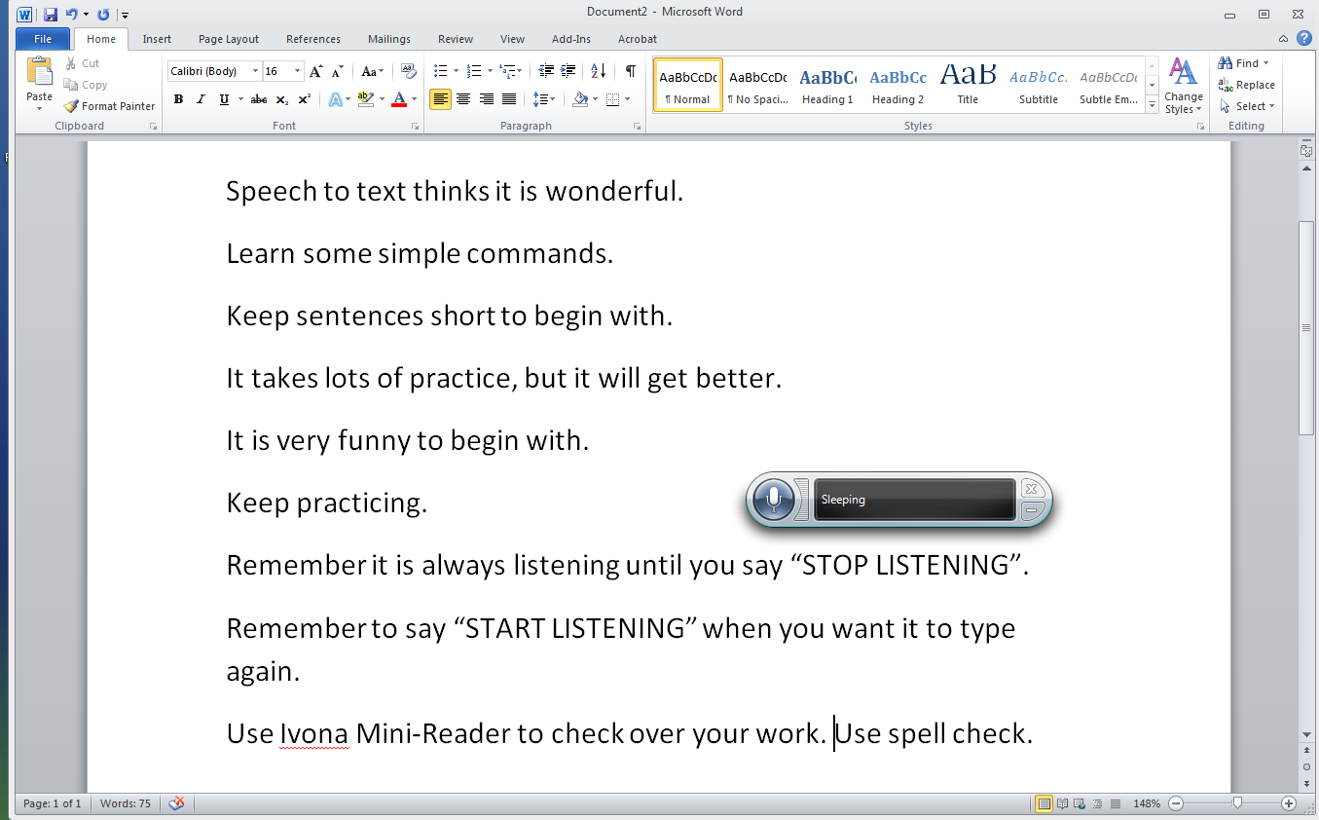
Speech to text thinks it is wonderful.
Learn some simple commands.
Keep sentences short to begin with.
It takes lots of practice, but it will get better.
It is very funny to begin with.
Keep practicing.
Remember it is always listening until you say “STOP LISTENING”.
Remember to say “START LISTENING” when you want it to type again.
Use Ivona Mini-Reader to check over your work. Use spell check too.
Start/ All Programmes/ Accessibility/ IVONA Minireader.
Start Stop Voice Speed Volume

Once set up you can access Speech to Text from the bottom toolbar Use Word Pad with Speech to text. Start/All Programmes/Accessories/Word pad.
Use Word Pad with Speech to text.
Start/All Programmes/Accessories/Word pad.
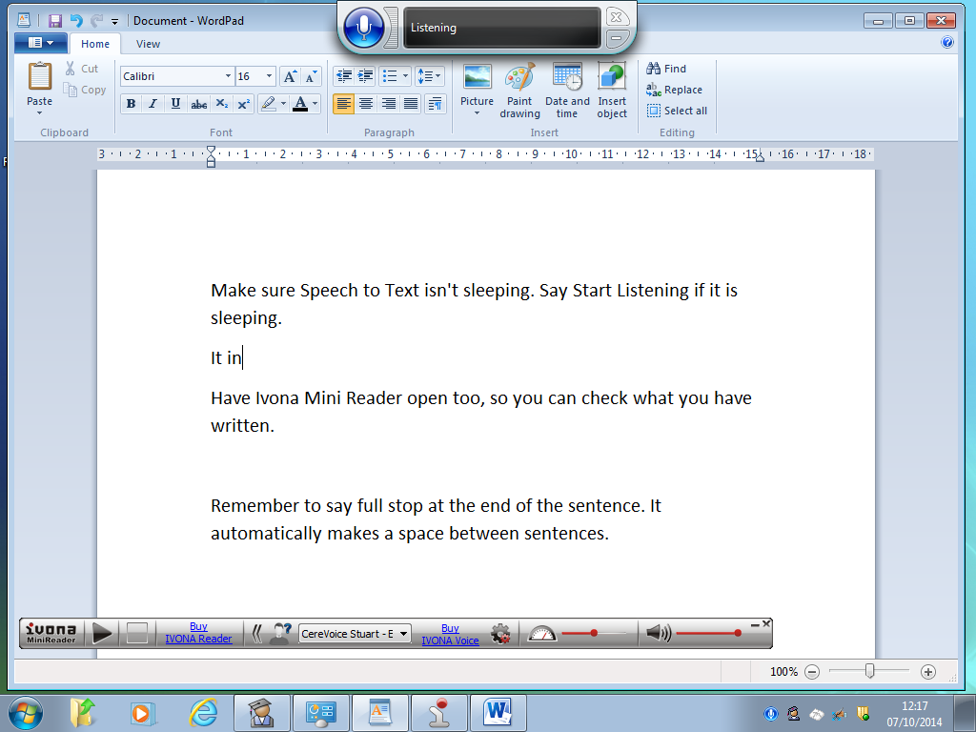

Start/ All Programmes/ Accessibility/ IVONA Minireader.
Start Stop Voice Speed Volume

To make this appear say this

To make this appear say this

To make this appear say this

To make this appear say this

To make this appear say this
To make this appear say this

