

Hello,
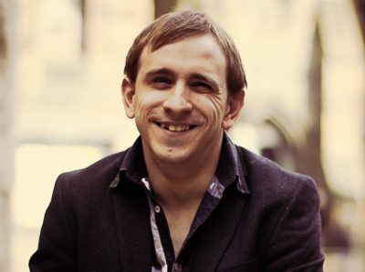
My name is Colin Young and I have Cerebral Palsy. I am working with Glasgow University to look at young peoples’ experiences of having Cerebral Palsy and having therapy such as physiotherapy, occupational therapy and speech and language therapy etc.

I’m writing to you as you have Cerebral Palsy and I understand you have been to therapy as you’ve been growing up.
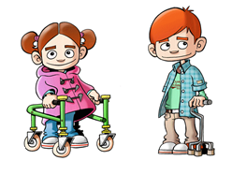
If it’s alright with you, I would like to interview you to ask you about your thoughts on the therapies you use. I will meet you on two occasions in a place you choose for around two hours each. I will ask you questions and talk to you about your experience. I will record our conversation and type it up. If it is alright with you I will bring my personal assistant to the interview, as he helps me to take notes. However, it is okay if you prefer not to have my PA at the interview. The things you tell me will be included in my research report. Your name will not appear anywhere on the report, so that everything you say is confidential.

It is your choice whether or not to take part in the research. If you do decide to participate, you will be given this information sheet to keep and be asked to sign a consent form. If you decide to take part you can stop at any time and you do not need to tell me why.

Contact information:

If you have any questions or would to talk, please contact me, Colin Young, on 07988724449 or at c.young.1@research.gla.ac.uk. You can also contact my supervisor who is Professor Nicholas Watson and can be contacted on nicholas.watson@gla.ac.uk.

If you have any worries about the way the interview was held or if you are not happy with the interviewer, please contact Dr Muir Houston, Ethics Officer, on 0141-330-4699 or email Muir.Houston@glasgow.ac.uk.

PARTICIPANT CONSENT FORM

Principal researcher:
- Colin Young, c.young.1@research.gla.ac.uk

Principal supervisor:
- Professor Nicholas Watson, nicholas.watson@gla.ac.uk.

I have read and understood the information sheet about this study and have had the opportunity to ask questions about it.
I understand that I do not have to take part, and can withdraw from the study at any time, without having to give a reason.
I understand that I will not be punished for not taking part or stopping.
I agree to my voice being recorded and to have my comments written into a report without my name.

I agree to participate in this interview.

Participant’s name: _____________________________

Signature: _____________________________

Date: _____________________________

Parent’s/guardian’s
Signature (if participant
is aged 16 or under): _____________________________

Date: _____________________________

