Balabolka
Contents
Balabolka 2
Getting Started 3
Balobolka Toolbar 3
Text Read Back While you Type 5
Change the Speech Settings 9
Open a document in Balabolka 11
Convert a Text File to an Audio File 13
Create Bookmarks 16
Split and Convert the Text File to Audio 18
Change the Background and Font Colour 21
Close Balabolka 24

Balabolka
Balabolka is a text-to-speech program that can import a wide range of text-based files, read them aloud, highlight words as they are read, and convert text to speech, e.g., MP3.is
Who would benefit?
Balabolka is for individuals who find it helpful to read and listen to text. Balabolka can also help those for whom English is not their first language.
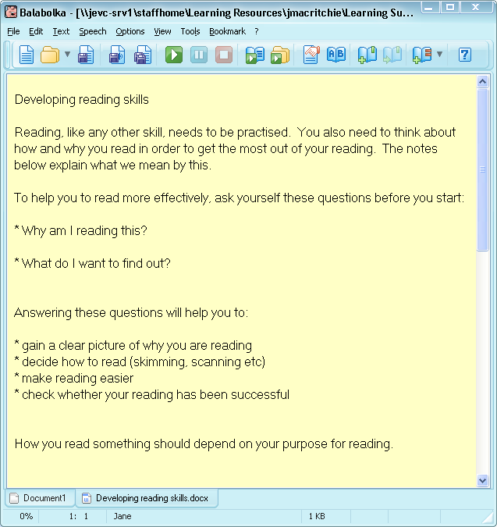
Main features:
- Imports a wide range of text-based files, e.g., Word, HTML etc.
- Highlights text as it is read.
- Saves text to audio format, e.g., MP3 and WAV.

Getting Started
- Click on the Writing icon on MyStudyBar and select Balabolka.
A new Balabolka document will appear.
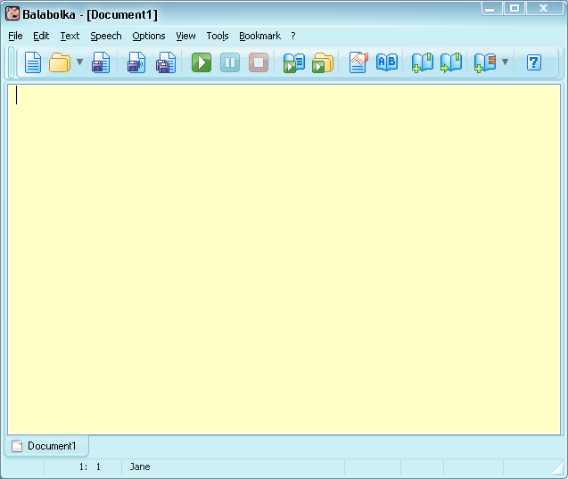

Balobolka Toolbar

 | New Balabolka Document |  | Configure Voice
 | Open a Document |  | Panel of Dictionaries
 | Save a document |  | Insert quick Bookmark
 | Save an Audio File |  | Go to Quick Bookmark
 | Split and Convert to Audio File |  | Insert Named Bookmark
 | Play |  | Help
 | Pause
 | Stop
 | Read Selected Text
 | Read Clipboard Aloud

Text Read Back While you Type

- Type the following text into the Balabolka document:

Use what talent you possess: the woods would be very silent if no birds sang except those that sang best.

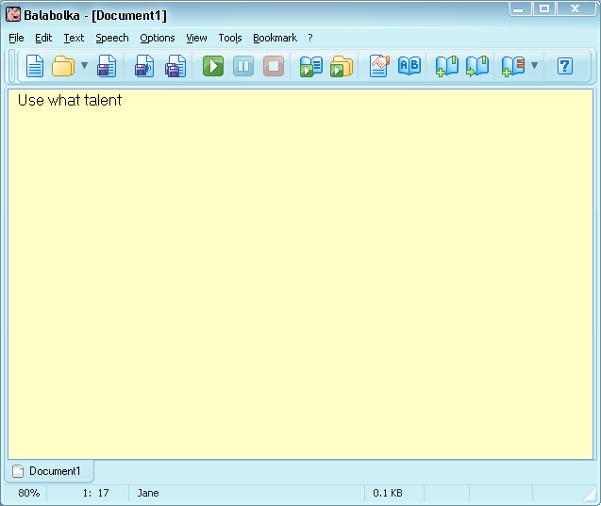

- As you type each word is read out to you.

- If you would like to hear the text again, place your cursor at the beginning of the text and press the Play icon.

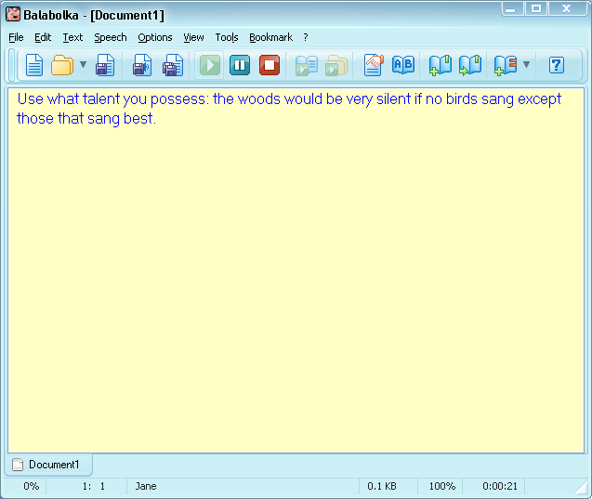
Spell Checking

Balabolka has a Spell Check facility that you can use to check if any words have been misspelt.

- If you spell a word incorrectly it will highlight in red.

- To correct the spelling, hover over the red text and right click. A list of possible words will appear for you to choose from. Left click to change the word.

- Alternatively you can perform a spell check on a document by selecting Text > Spell Checking.

- A pop up box will appear with a choice of words for you to choose from. Select the correct spelling and click Change.
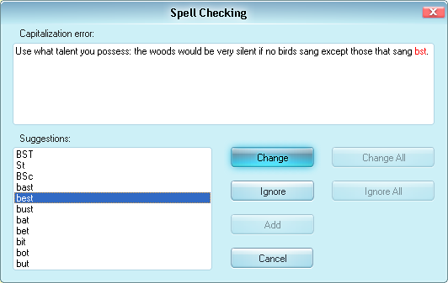

Change the Speech Settings

- It is possible to change the voice, rate and pitch of the speech settings. To do this select the Configure Voice Icon.
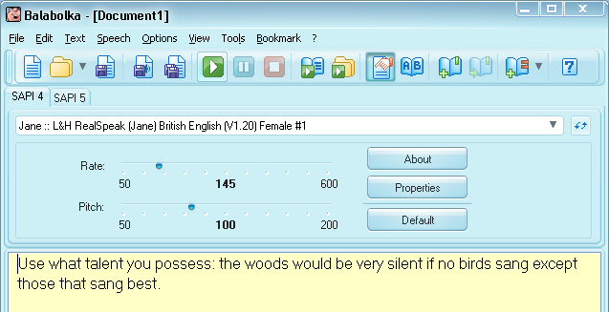
- If you would like to change the voice click on the drop down list and select a voice to try.
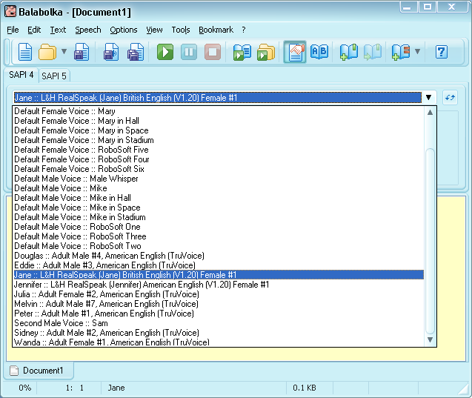
- Press the Play icon to test your new voice. (the default voice Jane British English is a good choice).

- You can also change the voice rate and pitch by moving the blue sliders.
- Click on the Configure Voice Icon close this.

Open a document in Balabolka

- You can open Word and PDF documents in Balabolka and have them read out to you. To do this click File >Open, and then browse to the file/s that you would like to open.

- The document will appear in the Balabolka application, ready for you to read out or edit.

- It is possible to navigate between documents by using the tabs at the bottom of the software application.

Convert a Text File to an Audio File
- With a document open click on the Save as Audio icon.
- Browse to the location you would like to save your audio file.

- Give your file the title Developing Reading Skills and then select the Type of audio file you would like and click Save.
- A progress bar will appear which will give you the option to Stop or Cancel the action.

- When the audio file has been saved, you can go to the location it is stored at and double click to play the file back

- A Media Player will appear and play your audio file.

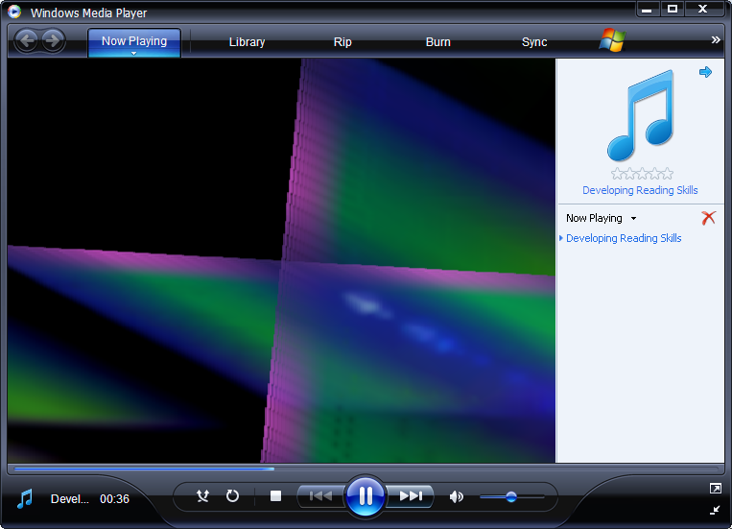

Create Bookmarks
To make navigating through long documents easier it is possible to break up documents by adding bookmarks.

- Place your cursor at the beginning of the document.
- Click on the Insert Named Bookmarks icon. A pop up box will appear, give the new bookmark a name, here the name Developing reading skills has been used.
- Scroll down the page and place your cursor at the beginning of the next section. Select the Insert Named Bookmarks icon.

- A popup box will appear asking you to name the bookmark. Here we will use the name Skimming and click OK.
- Now if you click on the drop down menu beside the Insert Named Bookmarks icon. You can navigate to the different sections by clicking on the named bookmark in the drop down menu.

Split and Convert the Text File to Audio

When you have created bookmarks in your document, you can then split and convert the text file to audio.
- Click on the Split and Convert to Audio File icon.
- A popup box will appear.

`
- Browse: For the location you would like to save your audio files in.
- Audio File Format: Select the format of your audio File.
- Split Method: tick the by named bookmarks
- Click the Split and Convert Button.

- You will next be asked to double check that the sections are correct. If they are select the Split button.

- A progress bar will appear, letting you know when the files have been saved to your location.

- You can browse to the location of the audio files and then you can double click to listen or transfer them to your mobile phone or MP3 player if a MP3 file extension was chosen.

Change the Background and Font Colour
- Select Font and Colours…

- A popup box will appear with colour changing options.

- To change font colour, size and style select the Font Button.
- To change the background colour, select the Background colour button and select the colour you would like to use.

- Highlight colour: changes the colour of text that has been read out.
- Selection colour: changes the background colour of highlighted text.
Selected text: changes the colour of the text that has been highlighted.

Close Balabolka

- To close the Balabolka application, select the File Menu and choose Exit.

