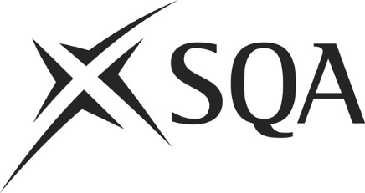

MYTHS
&
LEGENDS
1 | Digital Question papers are MS Word versions of the conventional examination question paper. | True  or  False
2 | SQA can only provide Digital Question Papers as an assessment arrangement for disabled candidates and/or those identified as having additional support needs. | True  or  False
3 | A candidate with dyslexia can be provided with assessment arrangements, including Digital Question Papers, if he/she does not have a psychologist’s report. | True  or  False
4 | SQA believes that too many candidates are being provided with Digital Question Papers. | True  or  False
5 | A centre must have evidence of a candidate’s current need for Digital Question Papers and that this reflects the candidate’s usual way of working in the classroom or support base. | True  or  False
6 | Candidates can dictate, with speech recognition software, their answers directly onto the Digital Question Paper. | True  Or  False

7 | Candidates cannot use the Digital Question Papers to use text-to-speech software to read back their responses | True  or  False
8 | The spellcheck must only be used where it has been authorised by SQA. | True  or  False
9 | All centres must submit their requests for Digital Question Papers by the end of January. | True  or  False
10 | You must provide separate accommodation when a candidate is using a Digital Question Paper. | True  or  False
11 | Using Digital Question Papers in the National 5 examinations automatically entitles the candidate to use them in the Higher examinations. | True  or  False
12 | Evidence of the school’s internal Assessment Arrangements verification meeting must be available before SQA will process any requests for Digital Question Papers. | True  or  False
13 | At the end of the examination, the invigilator must be present during the printing out of the candidate’s saved work. | True  or  False
14 | When you have printed out the hard copy of the candidates’ examination work, you can keep any material saved on the hard drive. | True  or  False
15 | Schools must use the Digital Answer Booklets from SQA when candidates type up answers for ‘question-only’ examinations | True  or  False

