T-Bar
Contents
T-Bar – Screen Masking 2
Get Started 3
Change the Height and Width of T-Bar 4
Lines Option 6
Multiple Lines 9
Close T-Bar 10

T-Bar – Screen Masking

T-bar is a coloured screen masking/ruler.
Who would benefit?
Individuals who prefer to use an alternative font and background colour to the Windows default.
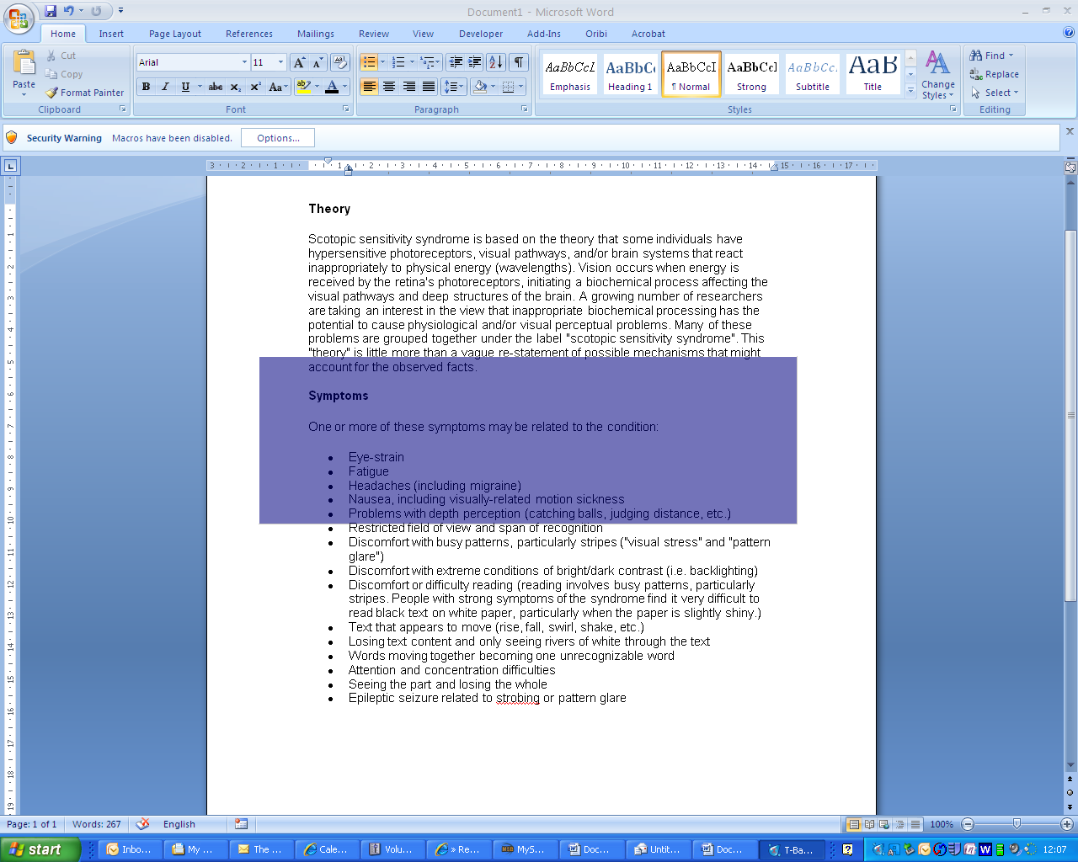
Main features:
- Screen masking with 1 or 2 ruled lines.
- Ruled lines can be adjusted to read one or more lines of text.
- Adjustable screen masking width and length.
- Lock T-bar so it follows the mouse pointer.

Get Started
- Launch T-Bar by clicking on the Reading icon on the MyStudyBar.
- Select T-Bar – Screen Masking
- When T-Bar first starts a movable coloured overlay will appear on the screen.
- To change the colour and size of the T-Bar, right click on the T-Bar icon located on the bottom toolbar of your screen.
- Select Controls, to change options.
- Select a colour and change the saturation to suit your needs, and then click OK.

Change the Height and Width of T-Bar
- To change the colour and size of the T-Bar, right click on the T-Bar icon located on the bottom toolbar of your screen.
- Select Controls, to change options.
- Click on the Bar Options tab and change the height and width of the T-bar to suit your needs.

- In the example below the width of the T-Bar extends across the whole screen.
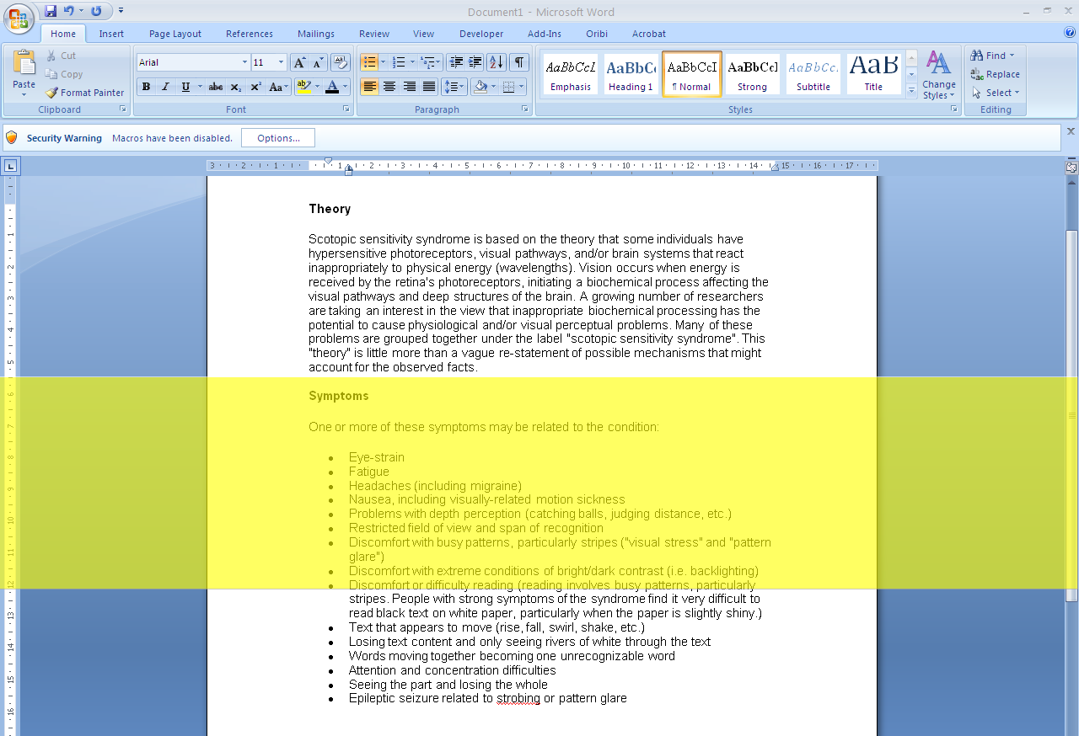

Lines Option
T-Bar provides a line option which can be extremely useful if you find that you lose your place whilst reading long pieces of text.
- To add a Line to the T-Bar, right click on the T-Bar icon located on the bottom toolbar of your screen.

- Select Controls, to change options.
- Select the Line Option Tab. Click on the Line button. This will create a line on the T-bar. Then you can select a colour and change the position and height of the line to suit your needs, using the controls in the Line 1 Section of the Controls panel.

- It is possible to move the T-Bar with your mouse or alternatively you can lock the T-Bar in place and use the keyboard arrow keys to move the T-Bar as you read the text.
To Lock the T-bar, right click on the T-Bar and select lock you can then use the arrow keys to move the T-Bar up and down.

- Clicking outside of the T-bar will automatically unlock it.

Multiple Lines
It is possible for T-Bar to create multiple lines if required.
- To add a second line, click on the Lines Button twice. You can change the height and position of this second line in the Line 2 Section of the pop up box.

Close T-Bar

- To close the right click on the T-Bar icon located on the bottom toolbar of your screen.
- Select Exit.

