Windows 11 Accessibility Essentials
A guide for schools and local authorities to comply with Scottish Government recommendations

Introduction
This paper details free Accessibility software that should be provided as standard on computers so that learners with Additional Support Needs and disabilities can access the school devices.
By providing these accessibility tools you help to meet Scottish Government recommendations and legal obligations to take reasonable adjustments and provide access under the Equality Act 2010.
These tools should be planned for and made available when systems are refreshed to meet Scottish Government guidance which states that:

“Computer refreshes or re-imaging are planned to accommodate existing assistive software and hardware used by disabled pupils.”

“Where computer refresh or re-imaging will result in current assistive technology not being usable, replacement or upgrade takes place so that the disabled pupil is not disadvantaged.”

Scottish Government guidance: accessibility

“Settings can be easily and quickly changed to enable access for each disabled pupil, including where needed facility for Right click functionality. Such adjustments can be saved with the user's profile. ”

“Staff and pupils are aware of specialist hardware and software installed and Control Panel options on schools computer, to enable access.”
Accessibility should be available for learners and staff. All tools within all the sections of Accessibility should be available on start up, from the Windows Start menu or alternatively as a keyboard shortcut - Windows + H.

*Although still available in Windows 11, Ease of Access is a legacy feature and is superseded by the improved Accessibility tools.
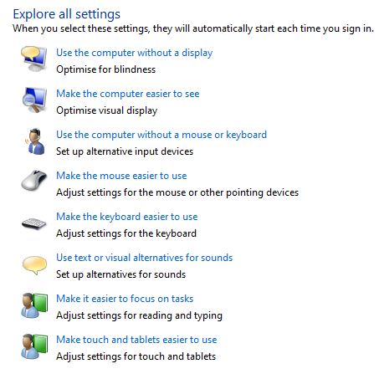

Suggested tools

Accessibility should be available for all learners and staff.

Vision | Hearing | Interaction
Display | Audio | Speech (Dictate should be available with Win + H keys
Mouse Pointer | Closed Captions | Keyboard
Text Cursor |  | Mouse
Magnifier |  | Eye-control
Colour Filters
High Contrast
Narrator

Rationale
Learners who require essential adjustments to the computer can have them.
For example, learners who -
- are visually impairment may require larger icons, text, mouse pointer or text cursor or to use the magnifier to zoom in on particular areas of the screen;
- are blind may need Narrator to read out the screen display and digital text;
- require closed captions should be able to choose an accessible font size;
- cannot use a physical keyboard may need the touch or onscreen keyboard;
- cannot use a mouse or alternative may need to use Mouse Keys on the keyboard;
- have motor control challenges may need to change mouse speed or keyboard settings;
- have difficulty typing may need Speech Dictation.

Learning Tools / Accessibility Shortcuts

- Create a folder on the desktop or in Start menu or tiles with shortcuts to the installed accessibility tools.
- Staff and learners are often unaware of learning / accessibility tools and options.
- Making them available on the desktop or in Start Menu or tiles makes them more obvious and easier to access.
The folder should contain shortcuts to the tools and we also suggest adding a selection of posters, video guides and resources on how to use the tools.

Scottish Government guidance: text-to-speech

“All school computers have text-to-speech (TTS) software installed for reading documents and web pages.”

Suggested tools
Office 365
- Learning Tools
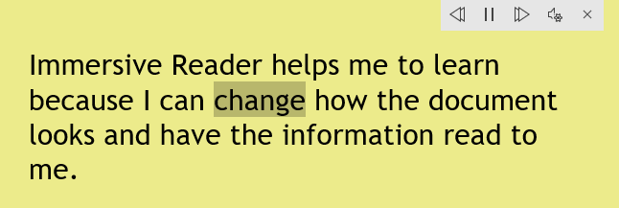
- Speak Button
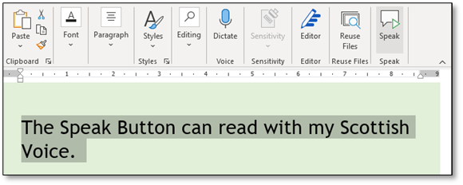
Office 2016 (see above)
- Learning Tools
- Speak Button

Rationale
Learning Tools and Immersive Reader are free tools that support reading and comprehension for learners with reading or literacy difficulties, i.e.,
- simplified layout;
- colour options;
- line focus;
- Read Aloud text reader;
- Picture Dictionary;
- Dictate.
The Speak Button should be added to the Office Desktop Ribbons because;
- it can read with Scottish voices (Immersive Reader can’t) and
- sometimes you just want to select some text and have it read out and you don’t want to use Immersive Reader because it changes the document layout.

Natural Reader 16
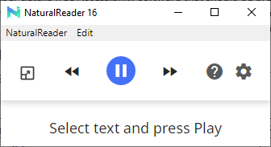

- Free universal text reader for the internet and PDFs including SQA Digital Question Papers.
- It can read with the Scottish voices.
- Add it to the shortcut to the Accessibility Folder.
Natural Reader is available to download for free from: www.naturalreaders.com/software.html
ATBar
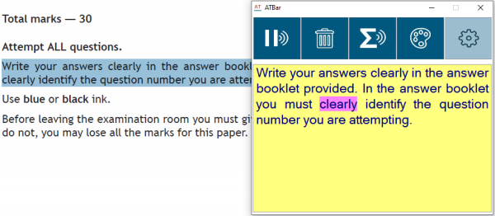
- Free universal text reader for the internet and PDFs including SQA Digital Question Papers.
- It reads with the Scottish voices.
- Add it as a shortcut to the Accessibility Folder.
- AT Bar can also run from a USB stick.
ATBar is available to download for free from: www.callscotland.org.uk/information/text-to-speech/atbar/
MyStudyBar 4
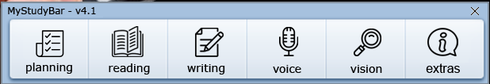
MyStudyBar provides similar, albeit not as sophisticated, functionality to commercial software such as Read&Write or ClaroRead.
MyStudyBar is a toolbar of free accessibility programs that provide, for example:
- Planning tools;
- Text reader (ATbar);
- Colour overlays, for learners with Scotopic sensitivity;
- System font size changer, to increase menu size for learners with visual impairment.
- Add it as a shortcut to the Accessibility Folder.
MyStudyBar is available to download for free from: http://www.callscotland.org.uk/blog/mystudybar-version-4/

Scottish Government guidance: computer voices

“All school computers accessed by pupils have the free Heather and Stuart voices installed.”

Suggested tools
- Heather & Stuart Scottish adult voices.
- Andrew and Mhairi Scottish child voices.
- Isla and Callum Scottish teenage voices.
- Ceitidh Scottish Gàidhlig voice.

Rationale
- All voicers free from http://www.thescottishvoice.org.uk
- Use with text readers so that learners can read with high quality Scottish accents and/or Gaelic voice.
- Set one of the voices to be the default voice in the Text to Speech Control Panel in Control Panel\All Control Panel Items\Speech Recognition\Text to Speech.

Text to Speech within Speech Recognition Control Panel
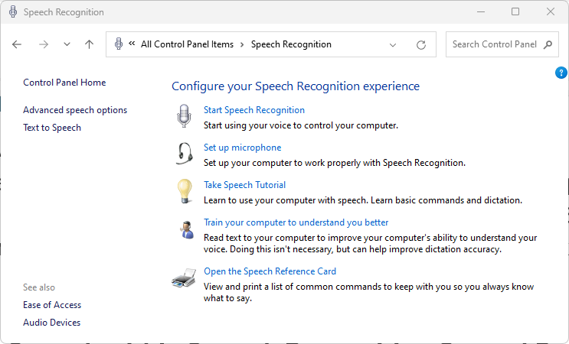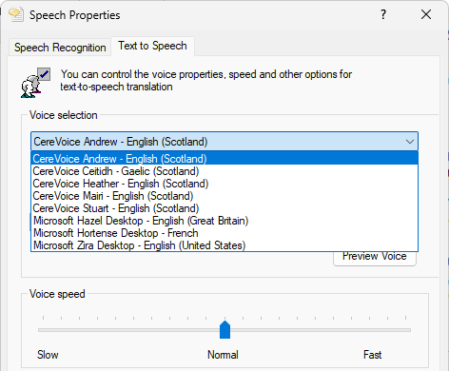

Students and practitioners should be able to access the Text to Speech properties to set the default computer voice so that for example, the Microsoft Word Speak button and Read Aloud in the spellcheck can use the student’s preferred voice.

Scottish Government guidance: assistive technology

“The school or local authority has a pathway or procedure and staff with expertise to:

Identify pupils who require ICT and/or AT to access the curriculum.

Assess and provide appropriate ICT and/or AT.”

“Specialist software required by learners with disabilities can be easily and quickly installed and used on school computers.”

“Specialist hardware required by learners with disabilities can be easily and quickly installed and used on school computers.”

“Personal devices used by disabled pupils for curriculum access can be connected to the school intranet.”

“Staff (teaching, support, librarian and technical) are made aware of legal obligations to provide access to the curriculum and to curriculum resources under Equality Duties, with particular reference to Guidance on Auxiliary Aids and Services.”

“Procurement decisions for hardware and software have due regard to accessibility and reasonable adjustment duties under the Equality Act. In particular, no extra cost should be charged for changes made to systems as part of reasonable adjustments made.”
Recommended Action | Rationale
Establish an Inclusive Digital Learning or Digital Accessibility Pathway so that specialist assistive technologies can be assessed, purchased, installed and supported “quickly and easily”.  Contracts with providers should ensure that specialist resources can be made available “quickly and easily” and without incurring additional costs. | Some learners require additional hardware or software to access digital technology. Some learners require more specialist assistive technology such as a low vision aid, a voice output communication device.  These devices may be regarded as ‘auxiliary aids’ under Equality and Accessibility legislation.  The Equality Act requires reasonable adjustments to be made and the need for such adjustments should be anticipated and planned.

Support and information
Are you meeting legal requirements for computer accessibility? (blog)
Using Windows 10 'Accessibility' Tools to Support Learners with Visual Difficulties (Poster)
Windows 10 Video Guides on Accessibility Tools for Learners with Visual Impairment (videos)
Windows 10 Accessibility Features (Microsoft web site)
Accessibility Tools for inclusive learning (Microsoft web site)
Microsoft Learn Educator Centre – Accessibility and inclusivity (Microsoft web site)
Windows Accessibility – YouTube playlist
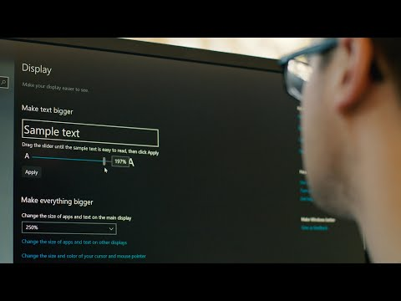

References
Planning improvements for disabled pupils’ access to education: Guidance for education authorities, independent and grant-aided schools, http://www.gov.scot/Publications/2014/10/8011, Appendix D & E.
Reasonable adjustments for disabled pupils - Auxiliary Aids Technical Guidance https://www.equalityhumanrights.com/en/publication-download/reasonable-adjustments-disabled-pupils-scotland
Technical guidance for schools in Scotland https://www.equalityhumanrights.com/en/publication-download/technical-guidance-schools-scotland
Disability Strategies and Pupils' Educational Records (Scotland) (Act) 2002 http://www.legislation.gov.uk/asp/2002/12/pdfs/asp_20020012_en.pdf
Additional Support for Learning - Legislation and Guidance http://www.scotland.gov.uk/Topics/Education/Schools/welfare/ASL

Planning improvements for disabled pupils’ access to education: Guidance for education authorities, independent and grant-aided schools, http://www.gov.scot/Publications/2014/10/8011, Appendix D & E.

