iPad (iOS) Accessibility Essentials

A guide for schools and local authorities to comply with Scottish Government recommendations

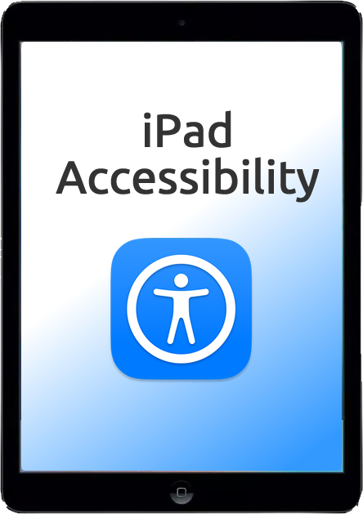

# **Introduction**

This paper details free Accessibility software that should be provided **as standard** on computers so that learners with Additional Support Needs and disabilities can access the school devices.

By providing these accessibility tools you help to **meet Scottish Government recommendations**[1] and legal obligations to take reasonable adjustments and provide access under the **Equality Act 2010.**

These tools should be planned for and made available when systems are refreshed to meet Scottish Government guidance which states that:

## “Computer refreshes or re-imaging are planned to accommodate existing assistive software and hardware used by disabled pupils.”

## “Where computer refresh or re-imaging will result in current assistive technology not being usable, replacement or upgrade takes place so that the disabled pupil is not disadvantaged.”

# Scottish Government guidance: accessibility

## “Settings can be easily and quickly changed to enable access for each disabled pupil, including where needed facility for Right click functionality. Such adjustments can be saved with the user's profile. ”

## “Staff and pupils are aware of specialist hardware and software installed and Control Panel options on schools computer, to enable access.”

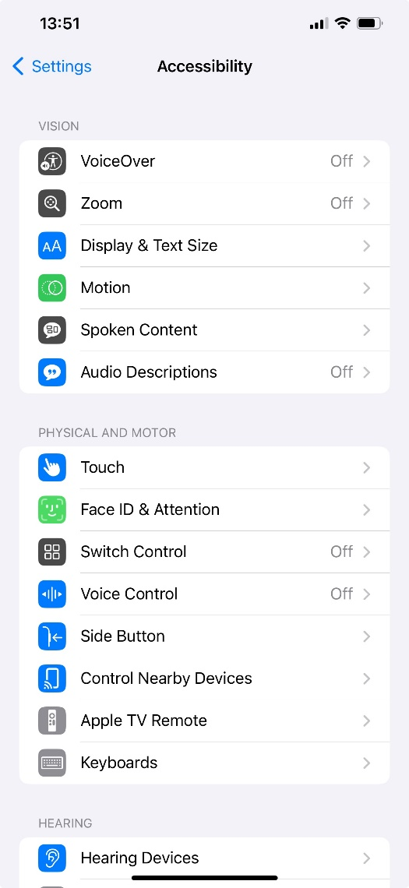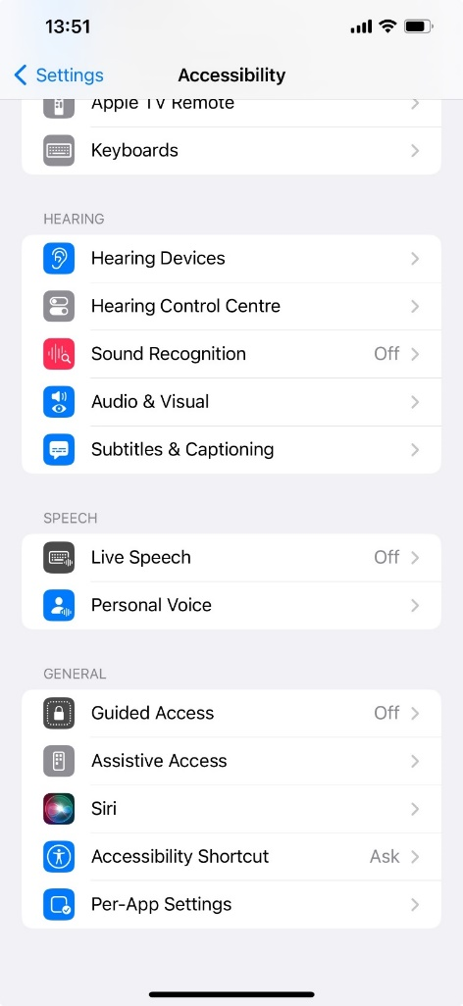

The Scottish Government guidance above was written for Windows 7 and today’s iPads have [Accessibility features](https://support.apple.com/en-gb/guide/ipad/ipad9a2465f9/ipados) rather than a Control Panel.

All tools within Accessibility features should be available for learners and staff.

Accessibility features should be available to pupils in the iPad Settings and via the [Control Centre](https://support.apple.com/en-gb/guide/ipad/ipade572ca56/17.0/ipados/17.0) or by [triple-clicking](https://support.apple.com/en-gb/guide/ipad/ipad9a245f9e/17.0/ipados/17.0) the Home or Power Buttons.

* [Apple Accessibility](https://youtube.com/playlist?list=PLIl2EzNYri0cLtSlZowttih25VnSvWITu&si=erB9gnms1rEXGuqo) (YouTube videos)
* [iPad short video guides to support reading and writing](https://youtube.com/playlist?list=PLm66eliPiNXOwdTttnxnJV7fK-yA1X7GZ) (Craig Mill’s YouTube playlist)
* [Jacob’s Quick Tips](https://www.jacobsquick.tips/) (short videos on iPads and iOS)
* [Glasgow Teachable Connected Learning](https://connected-learning-glasgow.teachable.com/) (courses on using iPads in school)
* [Apple Learning Community](https://education.apple.com/learning-center) (Apple courses and resources).

## **Suggested tools**

Accessibility features are available for learners and staff.

|  |  |  |  |  |
| --- | --- | --- | --- | --- |
| [**Vision**](https://support.apple.com/en-gb/guide/ipad/ipad4da14e91/17.0/ipados/17.0) | [**Mobility**](https://support.apple.com/en-gb/guide/ipad/ipad08f3d8dd/17.0/ipados/17.0) | [**Hearing**](https://support.apple.com/en-gb/guide/ipad/ipad2367604b/17.0/ipados/17.0) | [**Speech**](https://support.apple.com/en-gb/guide/ipad/ipad4f0d9bed/17.0/ipados/17.0) | [**Cognitive**](https://support.apple.com/en-gb/guide/ipad/ipaddc748989/17.0/ipados/17.0) |
| Screen tint and invert colours  Zoom  Magnifier  Mouse pointer  Font size  VoiceOver - screen reader | Voice Control, Siri and dictation  Predictive text  iPad on-screen keyboards  Hardware: keyboard, mouse, eye gaze and switch access  Touch Accommodations and Assistive Touch | Subtitles and captions  EarPods and hearing aids | Text to speech and record your own voice | Reduce distraction  Everyday support tools |

## **Rationale**

Learners who require essential adjustments to the iPad can have them.

For example, learners who;

* are **visually impairment** may require larger icons, text, mouse pointer or text cursor or to use the magnifier to zoom in on particular areas of the screen;
* have a **reading difficulty** can use Speak Selection or Speak Screen to read text;
* are **blind** may need VoiceOver to read out the screen display and digital text;
* require **closed captions** should be able to choose an accessible font size;
* cannot **use the touch screen** or onscreen keyboard may need an external mouse or pointing device or a hardware keyboard;
* have **motor control challenges** may need to change touch sensitivity or keyboard settings or use Assistive Touch to control the iPad;
* have **difficulty typing** may need Siri Dictation.

## **Learning Tools / Accessibility Shortcuts**

Add **Settings** to the Home Screen and/or to the iPad’s dock.

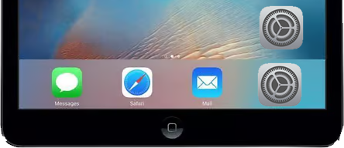

## **Rationale**

* Staff and learners are often unaware of learning / accessibility tools and options.
* Making them clearly available on the iPad makes them more obvious and easier to access.

# Scottish Government guidance: text-to-speech

## “All school computers have text-to-speech (TTS) software installed for reading documents and web pages.”

## “ All school computers have text-to-speech (TTS) software installed for reading documents and web pages. ”

## **Suggested tools**

### iPad [Spoken Content](https://support.apple.com/en-gb/guide/ipad/ipad9a247097/17.0/ipados/17.0) - Speak Selection, Speak Screen and Speech Controller.

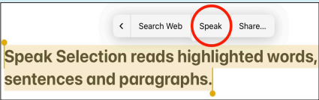

### [Office 365 Learning Tools](https://www.microsoft.com/en-gb/education/products/learning-tools)

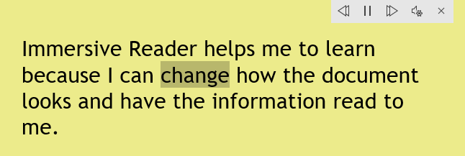

### [PDF reader](https://www.adapteddigitalexams.org.uk/setting-up-and-using/ipad/reading-digital-papers/)

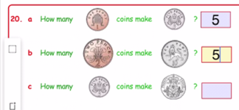

### **Rationale**

Learners with dyslexia, literacy challenges, English as an additional language, learning difficulties, visual impairment or hearing impairment can use text-to-speech to access text on the iPad.

If Microsoft 365 is used in school, learners will have access to Immersive Reader and the other Learning Tools in Office 365 online. These are free tools that support reading and comprehension e.g.,

* simplified layout;
* colour options;
* line focus;
* Read Aloud text reader;
* Picture Dictionary;
* Dictate.

Many learning resources such as worksheets, textbooks and SQA examination papers are PDFs and so pupils need a tool for accessing, reading and interacting with PDFs.

# Scottish Government guidance: text-to-speech

## “All school computers accessed by pupils have the free Heather and Stuart voices installed. ”

The Scottish Government guidance refers to the **free** Scottish and Gaelic voices available for Windows and MacOS from CALL Scotland’s [Scottish Voice](https://www.thescottishvoice.org.uk/home/) web site.

|  |  |
| --- | --- |
| Adult voice | Teenage / Child voice |
| Heather (adult female) | Andrew (male child) |
| Stuart (adult male) | Mairi (female child) |
| Ceitidh (Scottish Gaelic adult female) | Isla (female teenage) |
|  | Callum (male teenage) |

It is not yet technically possible to install the Scottish Voices on iPads although this is in development.

For general use on the iPad, you can download [Fiona](https://www.youtube.com/watch?v=T6ols9d9urQ), a Scottish adult female voice for iOS or alternatively you could consider making your own [Personal Voice](https://support.apple.com/en-gb/104993) on the iPad, or having a voice created with [SpeakUnique](https://www.speakunique.co.uk/) or [CereVoice Me](https://www.cereproc.com/en/products/cerevoiceme).

(Grid for iPad, the AAC app, has the Scottish voices, while Proloquo2Go, Proloquo4Text and TD Snap have Archie and Eilidh, Scottish child voices. These voices can only be used in the apps.)

## **Suggested Tools**

* iOS Scottish Fiona voice
* Record a Personal Voice for the iPad

### **Rationale**

* Learners can read with a high quality Scottish accent.

# Scottish Government guidance: accessibility

## “The school or local authority has a pathway or procedure and staff with expertise to:

## Identify pupils who require ICT and/or AT to access the curriculum.

## Assess and provide appropriate ICT and/or AT.”

## “Specialist software required by learners with disabilities can be easily and quickly installed and used on school computers.”

## “Specialist hardware required by learners with disabilities can be easily and quickly installed and used on school computers.”

## “Personal devices used by disabled pupils for curriculum access can be connected to the school intranet.”

## “Staff (teaching, support, librarian and technical) are made aware of legal obligations to provide access to the curriculum and to curriculum resources under Equality Duties, with particular reference to Guidance on Auxiliary Aids and Services.”

## “Procurement decisions for hardware and software have due regard to accessibility and reasonable adjustment duties under the Equality Act. In particular, no extra cost should be charged for changes made to systems as part of reasonable adjustments made.”

|  |  |
| --- | --- |
| **Recommended Action** | **Rationale** |
| Establish an Inclusive Digital Learning or Digital Accessibility Pathway so that specialist assistive technologies can be assessed, purchased, installed and supported “quickly and easily”.  Contracts with providers should ensure that specialist resources can be made available “quickly and easily” and without incurring additional costs. | Some learners require additional hardware or software to access digital technology.  The Equality Act requires reasonable adjustments to be made and the need for such adjustments should be anticipated and planned. |

# Support and information

[Apple Accessibility YouTube videos](https://youtube.com/playlist?list=PLIl2EzNYri0cLtSlZowttih25VnSvWITu&si=erB9gnms1rEXGuqo)

[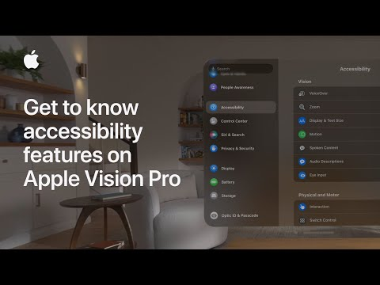](https://www.youtube.com/embed/videoseries?list=PLIl2EzNYri0cLtSlZowttih25VnSvWITu)

[iPad short video guides to support reading and writing](https://youtube.com/playlist?list=PLm66eliPiNXOwdTttnxnJV7fK-yA1X7GZ) (Craig Mill’s YouTube playlist)

[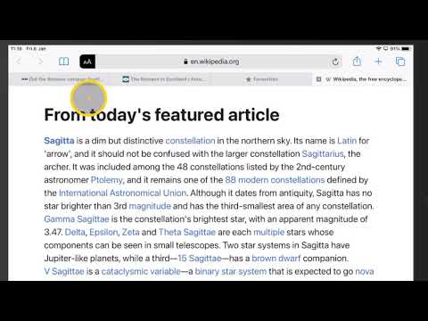](https://www.youtube.com/embed/videoseries?list=PLm66eliPiNXOwdTttnxnJV7fK-yA1X7GZ)

[Glasgow Teachable Connected Learning](https://connected-learning-glasgow.teachable.com/) (courses on using iPads in school, including [iOS Accessibility](https://connected-learning-glasgow.teachable.com/p/rtc-and-xma-accessibility-ios))

[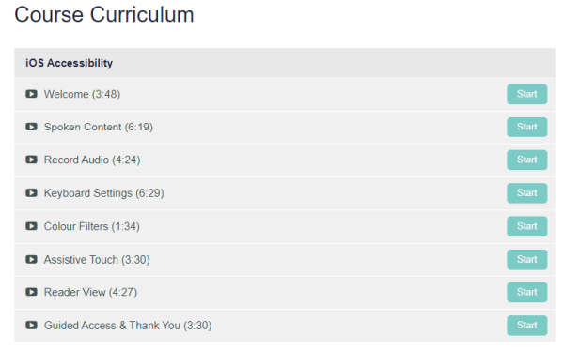](https://connected-learning-glasgow.teachable.com/p/rtc-and-xma-accessibility-ios)

[Jacob’s Quick Tips](https://www.jacobsquick.tips/) (short videos on iPads and iOS)

[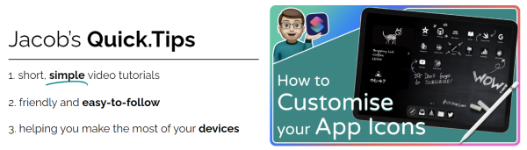](https://www.jacobsquick.tips/)

[Apple Learning Community](https://education.apple.com/learning-center) (Apple courses and resources including [iPad accessibility in the classroom](https://education.apple.com/learning-center/T021990A-en_EMEIA?backTo=))

[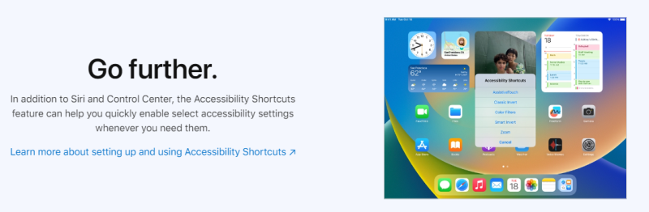](https://education.apple.com/learning-center/T021990A-en_EMEIA?backTo=)

## CALL Scotland posters and resources

[A complete beginners guide to the iPad](https://www.callscotland.org.uk/downloads/posters-and-leaflets/a-complete-beginners-guide-to-the-ipad/?bBZImH25AvyO30WnJap9)

[Are you meeting legal requirements for computer accessibility?](https://www.callscotland.org.uk/information/computer-accessibility/)

[iPad Apps for Complex Communication Support needs](https://www.callscotland.org.uk/downloads/posters-and-leaflets/ipad-apps-for-complex-communication-support-needs/)

[iPad Apps for Learners with Complex Additional Support Needs](https://www.callscotland.org.uk/downloads/posters-and-leaflets/ipad-apps-for-learners-with-complex-additional-support-needs/)

[iPad Apps for Learners with Dyscalculia/Numeracy Difficulties](https://www.callscotland.org.uk/downloads/posters-and-leaflets/ipad-apps-for-learners-with-dyscalculianumeracy-difficulties/)

[iPad apps for learners with dyslexia](https://www.callscotland.org.uk/downloads/posters-and-leaflets/ipad-apps-for-learners-with-dyslexia/)

[iPad Apps to Support Creativity](https://www.callscotland.org.uk/downloads/posters-and-leaflets/a-complete-beginners-guide-to-the-ipad/?bBZImH25AvyO30WnJap9)

[Setting up Guided Access on an iPad](https://www.callscotland.org.uk/downloads/posters-and-leaflets/setting-up-guided-access-on-an-ipad-ios-15/)

[Using the iPad to Support Dyslexia](https://www.callscotland.org.uk/downloads/posters-and-leaflets/using-the-ipad-to-support-dyslexia/)

[Using the iPad to Support Learners with Physical Difficulties](https://www.callscotland.org.uk/downloads/posters-and-leaflets/using-the-ipad-to-support-learners-with-physical-difficulties/)

[Using the iPad to Support Learners with Visual Difficulties](https://www.callscotland.org.uk/downloads/posters-and-leaflets/using-the-ipad-to-support-learners-with-visual-difficulties/)

# References

Planning improvements for disabled pupils’ access to education: Guidance for education authorities, independent and grant-aided schools, <http://www.gov.scot/Publications/2014/10/8011>, Appendix D & E.

Reasonable adjustments for disabled pupils - Auxiliary Aids Technical Guidance <https://www.equalityhumanrights.com/en/publication-download/reasonable-adjustments-disabled-pupils-scotland>

Technical guidance for schools in Scotland <https://www.equalityhumanrights.com/en/publication-download/technical-guidance-schools-scotland>

Disability Strategies and Pupils' Educational Records (Scotland) (Act) 2002 <http://www.legislation.gov.uk/asp/2002/12/pdfs/asp_20020012_en.pdf>

Additional Support for Learning - Legislation and Guidance <http://www.scotland.gov.uk/Topics/Education/Schools/welfare/ASL>

1. Planning improvements for disabled pupils’ access to education: Guidance for education authorities, independent and grant-aided schools, <http://www.gov.scot/Publications/2014/10/8011>, Appendix D & E.