Chromebook Accessibility Essentials
A guide for schools and local authorities to comply with Scottish Government recommendations

Introduction
This paper details free Accessibility software that should be provided as standard on computers so that learners with Additional Support Needs and disabilities can access the school devices.
By providing these accessibility tools you help to meet Scottish Government recommendations and legal obligations to take reasonable adjustments and provide access under the Equality Act 2010.
These tools should be planned for and made available when systems are refreshed to meet Scottish Government guidance which states that:

“Computer refreshes or re-imaging are planned to accommodate existing assistive software and hardware used by disabled pupils.”

“Where computer refresh or re-imaging will result in current assistive technology not being usable, replacement or upgrade takes place so that the disabled pupil is not disadvantaged.”

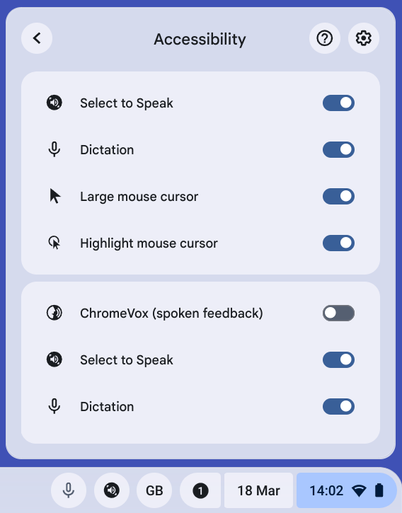

Scottish Government guidance: accessibility

“Settings can be easily and quickly changed to enable access for each disabled pupil, including where needed facility for Right click functionality. Such adjustments can be saved with the user's profile. ”

“Staff and pupils are aware of specialist hardware and software installed and Control Panel options on schools computer, to enable access.”
The Scottish Government guidance above was written for Windows 7, and today’s Chromebooks have Accessibility features rather than a Control Panel.
All tools within Accessibility features should be available for learners and staff.
Accessibility features should be available when the learner logs into the Chromebook, or via the bottom right, or via the Alt + Shift + s keyboard shortcut.
Chromebook Accessibility Interactive Tutorial.
Chrome and Chrome OS Accessibility Video Series
Making Chromebooks accessible for people with disabilities
CALL Scotland Chromebook Accessibility and Learning Tools.

Suggested tools
Accessibility features are available for learners and staff.
Display and Visuals | Audio and captions | Spoken feedback | Motor
Browser zoom  Display size  Full screen and Docked magnifier  Font size  Large mouse cursor  Invert colours  ChromeVox (screen reader) | Mono audio  Closed Captions | Select-to-Speak (text reader) | On-screen keyboard  Physical keyboard settings  Touchpad settings  Sticky keys  Dictation voice typing.  Press Search + d or Launcher + d.

Rationale
Learners who require essential adjustments to the Chromebook can have them.
For example, learners who;
- are visually impairment may require larger icons, text, mouse pointer or text cursor or to use the magnifier to zoom in on particular areas of the screen;
- have reading difficulty can use Select-to-Speak to read text;
- are blind may need ChromeVox to read out the screen display and digital text;
- require closed captions should be able to choose an accessible font size;
- cannot use a physical keyboard may need the touch or onscreen keyboard;
- cannot use a mouse or alternative may need to use Mouse Keys on the keyboard;
- have motor control challenges may need to change mouse speed or keyboard settings;
- have difficulty typing may need Dictation.

Learning Tools / Accessibility Shortcuts
Select the ‘Show Accessibility Settings in Quick Settings’ so that they can be easily accessed in the bottom right or pin the Settings to the Shelf.

Rationale
- Staff and learners are often unaware of learning / accessibility tools and options.

- Making them clearly available on the Chromebook makes them more obvious and easier to access.

Scottish Government guidance: text-to-speech

“All school computers have text-to-speech (TTS) software installed for reading documents and web pages.”

“ All school computers have text-to-speech (TTS) software installed for reading documents and web pages. ”

Suggested tools

Chrome Select-to-Speak
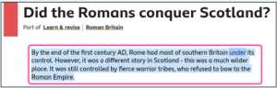

ClaroRead Chrome
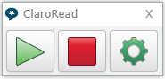
Read&Write for Google Chrome

Office 365 Learning Tools
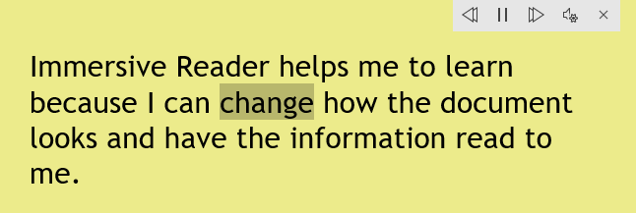

PDF reader
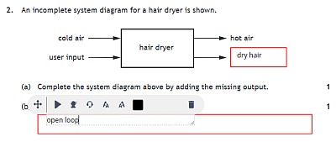

Rationale
Select to Speak
Learners with dyslexia, literacy challenges, English as an additional language, learning difficulties, visual impairment or hearing impairment can use Select-to-Speak to access text on the Chromebook.

ClaroRead, Read&Write and/or Natural Reader
ClaroRead, Read&Write and Natural Reader are text-to-speech extensions for Chrome. The free versions provide text-to-speech for reading text while the subscription versions add more features such as colour screen overlay, word prediction, spellcheck, picture dictionary, etc.

They can be easier to use than Speak Select and the free version of Read&Write offers Scottish accent voices and a Gaelic voice.
Office 365 Learning Tools
If Microsoft 365 is used in school, learners can use Immersive Reader and the other Learning Tools in Office 365 online. These are free tools that support reading and comprehension, e.g.,

- simplified layout;
- colour options;
- line focus;
- Read Aloud text reader;
- Picture Dictionary;
- Dictate.

PDF Readers
Many learning resources such as worksheets, textbooks and SQA examination papers are PDFs and so pupils need a tool for accessing, reading and interacting with PDFs such as Kami or OrbitNote.

Both these tools provide text-to-speech and drawing and annotation features.

Scottish Government guidance: computer voices

“All school computers accessed by pupils have the free Heather and Stuart voices installed.”

The Scottish Government guidance refers to the free Scottish and Gaelic voices available for Windows and MacOS from CALL Scotland’s Scottish Voice web site.
Adult voice | Teenage / Child voice
Heather (adult female) | Andrew (male child)
Stuart (adult male) | Mairi (female child)
Ceitidh (Scottish Gaelic adult female) | Isla (female teenage)
 | Callum (male teenage)

The voices are not yet available for downloading free to Chromebooks.
Read&Write for Google Chrome (including the free version) offers the Andrew, Heather, Stuart and Ceitidh voices.

Android versions of the adult voices can be purchased and installed on a Chromebook at a cost of 59p per voice - they can be used with Select-to-Speak and other text-to-speech tools on Chromebook.

Suggested Tools
- Heather & Stuart Scottish adult voices.
- Andrew and Mhairi Scottish child voices.
- Isla and Callum Scottish teenage voices.
- Ceitidh Scottish Gàidhlig voice.
- CereProc’s Android Voices are available from Google Play.
- Read&Write for Google Chrome (including the free version) comes with Andrew, Heather, Stuart and Ceitidh.
- ClaroRead for Chrome offers the Scottish Rhona adult female voice.

Rationale
- Learners can read with high quality Scottish and Gaelic accents: www.thescottishvoice.org.uk/home/
- Set one of the voices to be the default voice by following Craig’s instructions.

Scottish Government guidance: assistive technology

“The school or local authority has a pathway or procedure and staff with expertise to:

Identify pupils who require ICT and/or AT to access the curriculum.

Assess and provide appropriate ICT and/or AT.”

“Specialist software required by learners with disabilities can be easily and quickly installed and used on school computers.”

“Specialist hardware required by learners with disabilities can be easily and quickly installed and used on school computers.”

“Personal devices used by disabled pupils for curriculum access can be connected to the school intranet.”

“Staff (teaching, support, librarian and technical) are made aware of legal obligations to provide access to the curriculum and to curriculum resources under Equality Duties, with particular reference to Guidance on Auxiliary Aids and Services.”

“Procurement decisions for hardware and software have due regard to accessibility and reasonable adjustment duties under the Equality Act. In particular, no extra cost should be charged for changes made to systems as part of reasonable adjustments made.”
Recommended Action | Rationale
Establish an Inclusive Digital Learning or Digital Accessibility Pathway so that specialist assistive technologies can be assessed, purchased, installed and supported “quickly and easily”.  Contracts with providers should ensure that specialist resources can be made available “quickly and easily” and without incurring additional costs. | Some learners require additional hardware or software to access digital technology.  The Equality Act requires reasonable adjustments to be made and the need for such adjustments should be anticipated and planned.

Support and information
Chrome and Chrome OS Accessibility Video Series
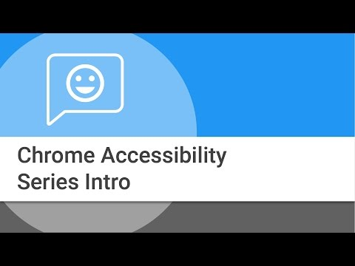
Chromebook Accessibility Interactive Tutorial.
Making Chromebooks accessible for people with disabilities
Google Accessibility Features (YouTube Playlist)
Are you meeting legal requirements for computer accessibility? (blog)
Chromebook Accessibility and Learning Tools (poster)
ChromeBook Apps and Extensions for Learners with Dyslexia (poster)
Using Select to Speak with a Scottish voice on a Chromebook (blog)

References
Planning improvements for disabled pupils’ access to education: Guidance for education authorities, independent and grant-aided schools, http://www.gov.scot/Publications/2014/10/8011, Appendix D & E.
Reasonable adjustments for disabled pupils - Auxiliary Aids Technical Guidance https://www.equalityhumanrights.com/en/publication-download/reasonable-adjustments-disabled-pupils-scotland
Technical guidance for schools in Scotland https://www.equalityhumanrights.com/en/publication-download/technical-guidance-schools-scotland
Disability Strategies and Pupils' Educational Records (Scotland) (Act) 2002 http://www.legislation.gov.uk/asp/2002/12/pdfs/asp_20020012_en.pdf
Additional Support for Learning - Legislation and Guidance http://www.scotland.gov.uk/Topics/Education/Schools/welfare/ASL

Planning improvements for disabled pupils’ access to education: Guidance for education authorities, independent and grant-aided schools, http://www.gov.scot/Publications/2014/10/8011, Appendix D & E.

