Chromebook Accessibility Essentials

This paper details free Accessibility tools that should be provided as standard on Chromebooks so that learners with Additional Support Needs and disabilities can access school devices.
By providing these accessibility tools you help to meet Scottish Government recommendations and legal obligations to take reasonable adjustments and provide access under the Equality Act.
The Scottish Government guidance was published in 2014 before Chromebooks were widely used by learners in schools and so this document interprets the guidance for Chromebooks.
Provision of these tools should be planned for and made available when systems are refreshed to meet Scottish Government guidance which states that:

“Computer refreshes or re-imaging are planned to accommodate existing assistive software and hardware used by disabled pupils.”

“Where computer refresh or re-imaging will result in current assistive technology not being usable, replacement or upgrade takes place so that the disabled pupil is not disadvantaged.”

Scottish Government guidance:

“Control Panel settings can be easily and quickly changed to enable access for each disabled pupil, including where needed facility for Right click functionality. Such adjustments can be saved with the user's profile.”

“Staff and pupils are aware of specialist hardware and software installed and Control Panel options on schools computer, to enable access”

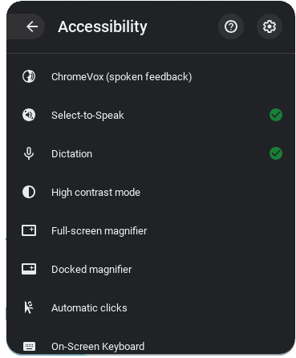

The Scottish Government guidance above was written for Windows 7, and today’s Chromebooks have Accessibility features rather than a Control Panel.
All tools within Accessibility features should be available for learners and staff.
Accessibility features should be available when the learner logs into the Chromebook, or via the bottom right, or via the Alt + Shift + s keyboard shortcut.
Chromebook Accessibility Interactive Tutorial.
Chrome and Chrome OS Accessibility Video Series
Making Chromebooks accessible for people with disabilities
CALL Scotland Chromebook Accessibility and Learning Tools.
Recommended Tools | Rationale
Accessibility features are available for learners and staff.  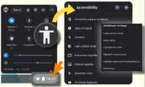  Display and Visuals  - Browser zoom  - Display size  - Full screen and Docked magnifier  - Font size  - Large mouse cursor  - Invert colours  - ChromeVox (screen reader)  Audio and captions  - Mono audio  - Closed Captions  Spoken feedback  - Select-to-Speak (text reader)  Motor  - On-screen keyboard  - Physical keyboard settings  - Touchpad settings  - Sticky keys  - Dictation voice typing. Press Search + d or Launcher + d. | Learners who require essential adjustments to the Chromebook can have them.  For example, learners who  - are visually impairment may require larger icons, text, mouse pointer or text cursor or to use the magnifier to zoom in on particular areas of the screen;  - have reading difficulty can use Select-to-Speak to read text;  - are blind may need ChromeVox to read out the screen display and digital text;  - require closed captions should be able to choose an accessible font size;  - cannot use a physical keyboard may need the touch or onscreen keyboard;  - cannot use a mouse or alternative may need to use Mouse Keys on the keyboard;  - have motor control challenges may need to change mouse speed or keyboard settings;  - have difficulty typing may need Dictation.

Learning Tools / Accessibility Shortcuts  - Create a folder on the desktop or in Start menu or tiles with shortcuts to the installed accessibility tools. | Staff and learners are often unaware of learning / accessibility tools and options.  Making them clearly available on the Chromebook makes them more obvious and easier to access.

Scottish Government guidance:

“All school computers have text-to-speech (TTS) software installed for reading documents and web pages.”

Suggested Tools | Rationale
Chrome Select-to-Speak  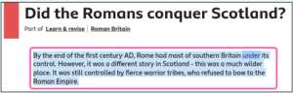  ClaroRead Chrome (free and subscription))  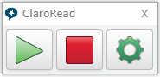  Read&Write for Google Chrome (free and subscription)  Office 365 Learning Tools  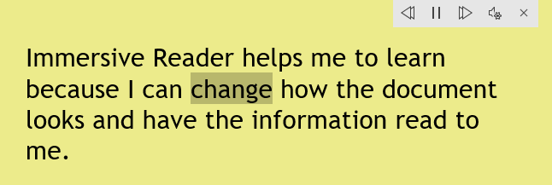 | Learners with dyslexia, literacy challenges, English as an additional language, learning difficulties, visual impairment or hearing impairment can use Select-to-Speak to access text on the Chromebook.  Free ClaroRead provides text-to-speech and a coloured screen overlay. The premium version has other features such as spellcheck and mind-mapping.  The free Read&Write provides text-to-speech. Premium Read&Write has other tools to support literacy.  If Microsoft 365 is used in school, learners will have access to Immersive Reader and the other Learning Tools in Office 365 online. These are free tools that support reading and comprehension for learners with reading or literacy difficulties, i.e.  - simplified layout;  - colour options;  - line focus;  - Read Aloud text reader;  - Picture Dictionary;  - Dictate.

Scottish Government guidance:

“All school computers accessed by pupils have the free Heather and Stuart voices installed”.

The Scottish Government guidance refers to the free Scottish and Gaelic voices available for Windows and MacOS from CALL Scotland’s Scottish Voice web site.
Heather (adult female) | Andrew (male child)
Stuart (adult male) | Mairi (female child)
Ceitidh (Scottish Gaelic adult female) | Isla (female teenage)
 | Callum (male teenage)

Android versions of the adult voices can be purchased and installed on a Chromebook at a cost of 59p per voice. We hope to make them available free of charge for all learners in Scotland in the future.
Read&Write for Google Chrome (including the free version) comes with Andrew, Heather, Stuart and Ceitidh.
Recommended Tools | Rationale
- Heather & Stuart Scottish adult voices.  - Andrew and Mhairi Scottish child voices.  - Isla and Callum Scottish teenage voices.  - Ceitidh Scottish Gàidhlig voice. | - CereProc’s Android Voices are available from Google Play.  - Read&Write for Google Chrome (including the free version) comes with Andrew, Heather, Stuart and Ceitidh.  - Learners can read with high quality Scottish and Gaelic accents.  - Set one of the voices to be the default voice by following Craig’s instructions.

Scottish Government guidance:

“Specialist software required by learners with disabilities can be easily and quickly installed and used on school computers.”

“Specialist hardware required by learners with disabilities can be easily and quickly installed and used on school computers.”

“Staff (teaching, support, librarian and technical) are made aware of legal obligations to provide access to the curriculum and to curriculum resources under Equality Duties, with particular reference to Guidance on Auxiliary Aids and Services.”

“Procurement decisions for hardware and software have due regard to accessibility and reasonable adjustment duties under the Equality Act. In particular, no extra cost should be charged for changes made to systems as part of reasonable adjustments made.”

Recommended Action | Rationale
Establish a Digital Accessibility Pathway so that assistive technologies can be assessed, purchased, installed and supported “quickly and easily”.  Contracts with technology providers should ensure that specialist resources can be made available “quickly and easily” and without incurring additional costs. | Some learners require additional hardware or software to access digital technology.  The Equality Act requires reasonable adjustments to be made and the need for such adjustments should be anticipated and planned.  The duty applies to services procured from commercial firms as well as those provided in house by local authority technical teams.

Support and information
Chrome and Chrome OS Accessibility Video Series
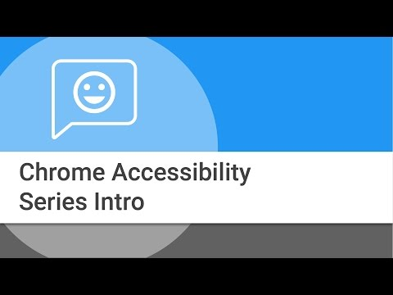
Chromebook Accessibility Interactive Tutorial.
Making Chromebooks accessible for people with disabilities
Google Accessibility Features (YouTube Playlist)
Are you meeting legal requirements for computer accessibility? (blog)
Chromebook Accessibility and Learning Tools (poster)
ChromeBook Apps and Extensions for Learners with Dyslexia (poster)
Using Select to Speak with a Scottish voice on a Chromebook (blog)

References
Planning improvements for disabled pupils’ access to education: Guidance for education authorities, independent and grant-aided schools, http://www.gov.scot/Publications/2014/10/8011, Appendix D & E.
Reasonable adjustments for disabled pupils - Auxiliary Aids Technical Guidance https://www.equalityhumanrights.com/en/publication-download/reasonable-adjustments-disabled-pupils-scotland
Technical guidance for schools in Scotland https://www.equalityhumanrights.com/en/publication-download/technical-guidance-schools-scotland
Disability Strategies and Pupils' Educational Records (Scotland) (Act) 2002 http://www.legislation.gov.uk/asp/2002/12/pdfs/asp_20020012_en.pdf
Additional Support for Learning - Legislation and Guidance http://www.scotland.gov.uk/Topics/Education/Schools/welfare/ASL

Planning improvements for disabled pupils’ access to education: Guidance for education authorities, independent and grant-aided schools, http://www.gov.scot/Publications/2014/10/8011, Appendix D & E.

