Contents
Creating accessible slide presentations 2
Introduction – why create accessible presentations? 2
Getting started 2
Designing for diverse learners 2
1. Use the built-in slide themes and templates 2
2. Reading order 3
3. Use accessible colours and styles 4
4. Use Slide/Page Numbers to aid navigation 4
5. Use Action Buttons to create interactivity and aid navigation 4
6. Add text to images for learners with visual difficulties 5
7. Use meaningful hyperlinks 6
8. Using PowerPoint’s Accessibility Checker 6
9. Presenting your slides with Subtitles 7
10. Adding captions 7
Useful Resources 8

Creating accessible slide presentations

Introduction – why create accessible presentations?
If you are creating presentations for your learners it is essential they are accessible and inclusive so all your learners can use them. Not only is it the right thing to do, it is also a legislative requirement, e.g., the Equality Act requires that we make reasonable adjustments to ensure learning materials are accessible and inclusive.
Below are some easy step-by-step instructions to ensure all your presentations are universally designed for all learners.
Although the emphasis here is on PowerPoint, the same rules apply to other presentation tools such as Google Slides and Keynote for Macs and iPads.

Getting started
Creating accessible documents and slides has many benefits; it can improve your workflow and improve your confidence, engage your learners while allowing them to customise the slides to suit their needs.

Designing for diverse learners
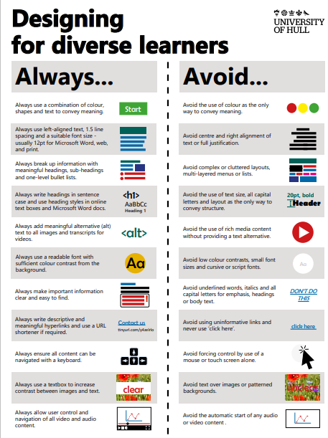
There are some universal guidelines which can be used on all documents and slides to support the needs of different learners. These include:
- Use a non-serif font (such as Arial, Calibri, Verdana, Tahoma).
- Ensure the font is no smaller than 12pt and text is left aligned.
- Avoid underlined and italicised text.
- Ensure images and videos include a text alternative (particularly for visually impaired learners who are unable to see the image and require a text description).
- Avoid using colour alone to convey meaning.
The poster, ‘Designing for diverse learners’ is an illustrated guide to get you started: bit.ly/designing-for-diverse-learners
Figure 1 Designing for diverse learners poster.

Use the built-in slide themes and templates
Microsoft PowerPoint, Google Slides and Keynote includes numerous built-in themes and templates which contain fields for Titles, Content, Section Headings, Content with Caption, which are by default accessible.
To use a PowerPoint built-in theme/template:
- Select the Home Tab and New Slide – choose a suitable slide from the drop down menu (see Figure 1 below).
- To add a Design to the slides select the Design Tab and choose an appropriate design template (see Figure 2).
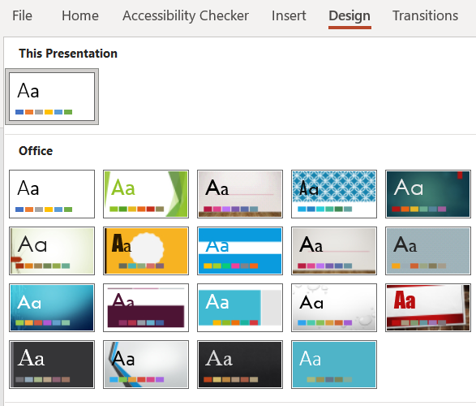
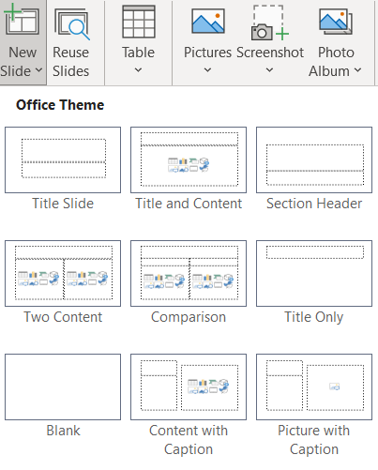

Figure 3: Use the built-in Design/themes
Figure 2: Choose a PowerPoint Template
Alternatively you can do a search for ‘Accessible’ using the online Office Themes search box.
To narrow down the search use ‘Accessible Education’ similar to the illustration below.
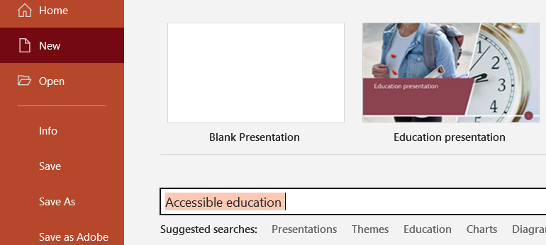
Figure 4: Use the online Office Themes to find accessible slides

Reading order
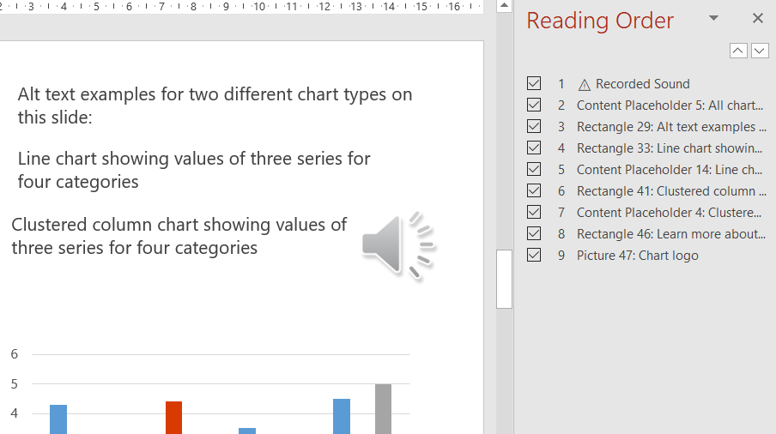
Where possible try to incorporate a ‘heading structure or order’ into your slides by using the text boxes provided in the themes and templates. These offer a logical reading order allowing learners to follow the content, particularly learners who require a screen reader to navigate the slides and information within the slides.
This is important if you have numerous elements on the slide, such as text columns, images and audio as it helps a learner using a screen reader to understand the slide.
You can adjust the reading order by using the Reading Order pane – see 8. PowerPoint’s Accessibility Checker for more.
Figure 5: Adjust the reading order to create a logical order in the slide.

Use accessible colours and styles
- Try to avoid patterned or textured backgrounds. Off white colours such as cream can help with perceptual difficulties.

- If you add text to an image or a background, ensure there is sufficient colour contrast between both elements so the text is readable.

- The colours and styles you use for slides, text, charts, and graphics go a long way toward improving accessibility in PowerPoint.

Use Slide/Page Numbers to aid navigation
If your presentation contains a large number of slides consider using Slide/Page numbers to help learners navigate through the slides in the presentation, i.e., learners who use a screen reader.
Select the Insert Tab and choose ‘Slide Number’. The number will appear at the bottom of the slide.
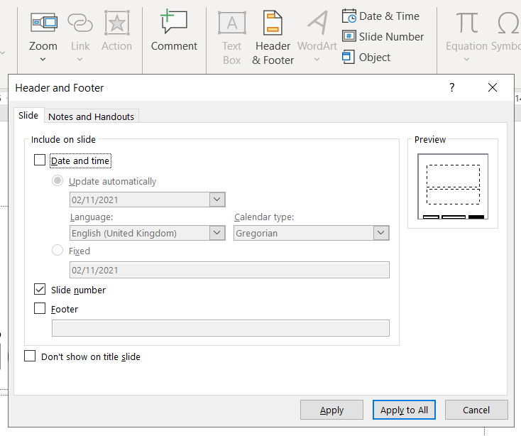
Figure 6: Add slide numbers to the slide to help navigation.

Use Action Buttons to create interactivity and aid navigation
If your presentation has been designed to be interactive, e.g., moving between different slides with media such as video, audio etc.
Action Buttons provide an accessible method as the Tab key on a keyboard can be used to navigate without using a mouse. For example, someone with a physical difficulty who is unable to use a mouse, but can use a keyboard or switch access.
- Action Buttons can also be used to play videos, audio and other media formats by assigning ‘actions’ to the button.

- Go to the Insert Tab and select Shapes. Action Buttons are located at the bottom.
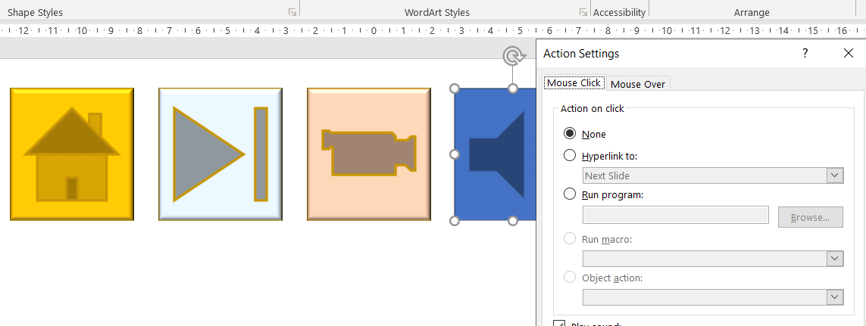
Figure 7: Use Action Buttons to creating interactivity and internal navigation.

Add text to images for learners with visual difficulties
PowerPoint is a graphical platform which includes a range of tools to be ‘graphically imaginative’, e.g., background images, photos, charts and other information which may convey information.
However, it is important to be mindful of those who are unable to see the images and require an alternative method to access the presentation, e.g., blind learners who use a screen reader.
It is therefore best practice to avoid using images alone to convey information. Also, wherever possible, avoid using only a background image on a slide to convey information.
There is a feature in PowerPoint (and most word processors and slide tools) to add a ‘caption’ or ‘text’ to an image which will be read by a screen reader.
In the example below there is an image of a chart inserted into a slide. For a sighted learner it is relatively easy to see, at a glance, the information conveyed in the chart.
To make this chart accessible use the ‘Alt Text’ tool to add a description to the chart.
- Adding ‘Alt Text’ or alternative text to an image can convey the information of the image to a screen reader.
Figure 8: Example of an chart/graph image in PowerPoint
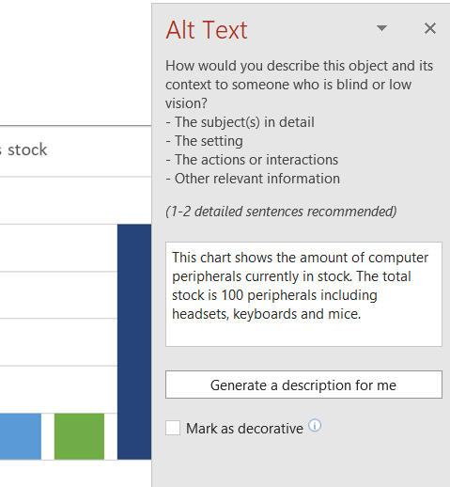
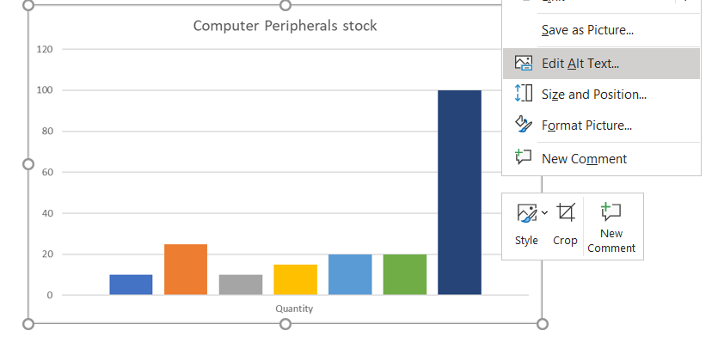
Figure 9: Use Alt Text to add information to the image.
- To add Alt Text, right click on the image (or use the right click keyboard command) and select ‘Edit Alt Text’.

- If the image is decorative, tick or check the box ‘Mark as decorative’.

Use meaningful hyperlinks
Hyperlinks can enhance presentations by signposting learners to additional or external resources. When adding hyperlinks to slides ensure they are meaningful. Avoid writing ‘click here’, ‘click here’ hyperlinks as this is confusing to someone using a screen reader.
- Avoid copying and pasting long hyperlinks into a slide.
- To add a meaningful hyperlink select the text/hyperlink and go to the Insert Tab and choose ‘Link’. Or alternatively right click on the text and choose ‘Link’ from the drop down menu.

- When the Insert Hyperlink window appears type the URL or link address in the ‘Address’ field at the bottom.
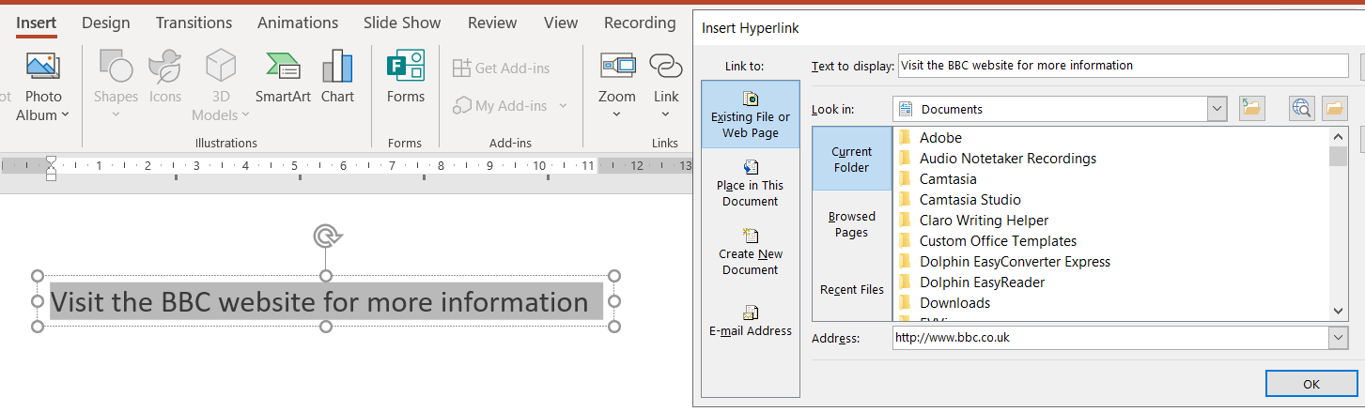
- Select the ‘Okay’ button when complete.

Figure 10: Use Insert Hyperlink to create meaningful links.

Using PowerPoint’s Accessibility Checker
PowerPoint has a built-in Accessibility Checker to ensure your final presentation is accessible by offering suggestions to amend any potential errors.
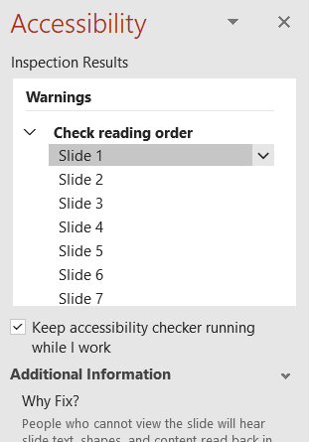
To find Accessibility Checker select the Review Tab and Check Accessibility.
- You can check items such as Alt Text, Reading Order and finely tune Accessibility using ‘Options’.
- There is also an option to check accessibility as you are working, prompting or alerting you to any issues.
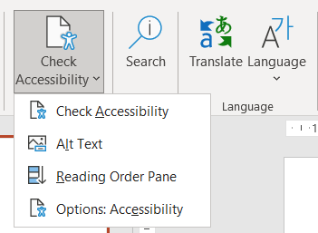

Figure 11: Check Accessibility In PowerPoint.

Presenting your slides with Subtitles
When presenting PowerPoint or Google Slides there is an option to use Subtitles, which appear when you start talking/presenting. Subtitles can help learners with a hearing impairment and also learners of other languages as the subtitles can be converted to other languages, e.g., English to Polish or French.
- To turn on and adjust Subtitles in PowerPoint select Slide Show and tick ‘Always Use Subtitles’. Subtitles will appear automatically when you turn on ‘Slide Show’ and start to talk/present.
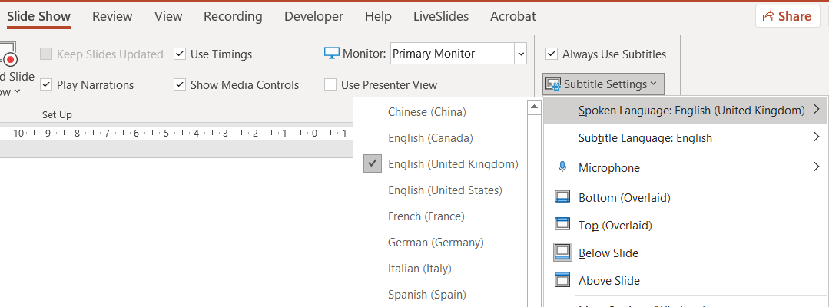
Figure 12: Turn on Subtitles in PowerPoint.
To turn on and adjust Subtitles in Google Slides select the ‘3 horizontal buttons’ on slide show mode or use the keyboard shortcut Ctrl + Shift + C.
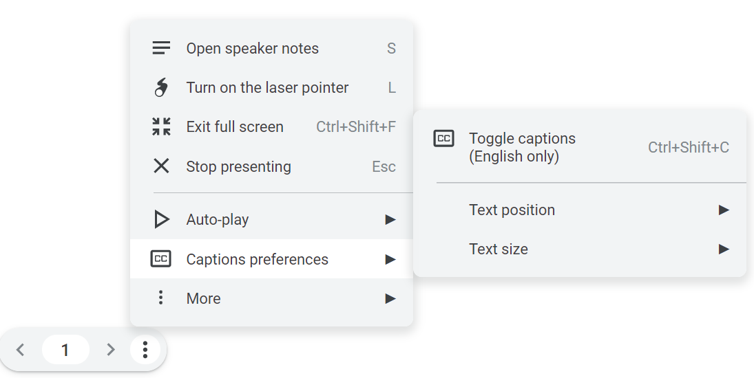
Figure 13: Turn on subtitles in Google Slides.

Adding captions
Adding subtitles or captions to video (and audio) is labour intensive and time consuming, yet vital for those who are deaf or hard of hearing. Recent developments have enable captions to appear on video automatically, i.e., auto captions.
If videos or audio are embedded into slides one option to provide auto captions is to use the built-in captions in Google Chrome. There is an illustrated tutorial on the CALL website: www.callscotland.org.uk/blog/live-captioning-in-google-chrome/
- If you are using Teams to present slides, auto captioning is available in ‘More Actions’ and ‘Turn on Live Captions’.

- If the Teams meeting is recorded with captions, captions can be edited in Microsoft Stream to improve accuracy which can be shared with learners.
There is also caption software that offer accurate captioning on a range of platforms;
- Caption.Ed – which includes a Google Chrome extension: https://caption-ed.com/

- Otter.ai – converts audio recordings to text/captions: https://otter.ai/

Useful Resources
CALL Scotland infograph ‘Inclusive Learning Resources’ bit.ly/inclusive-learning-resources
CALL Scotland infograph ‘Are you meeting your legal requirements for computer accessibility?’ bit.ly/computer-accessibility-requirements
The Welsh Government offers a short step-by step guide on creating accessible PowerPoints: bit.ly/welsh-gov-accessible-PPTs
The UK Government ‘Accessibility in Government has a range of illustrated posters on the ‘dos and don’ts of designing for accessibility’ offering general guidelines and best design practices: bit.ly/dos-donts-accessibility
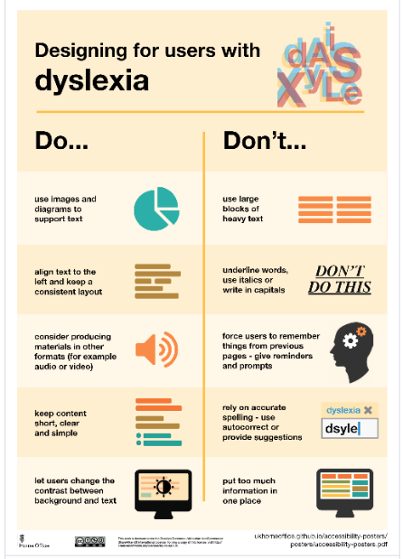
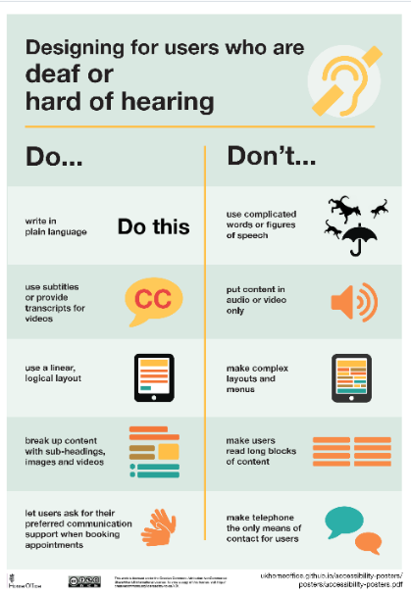
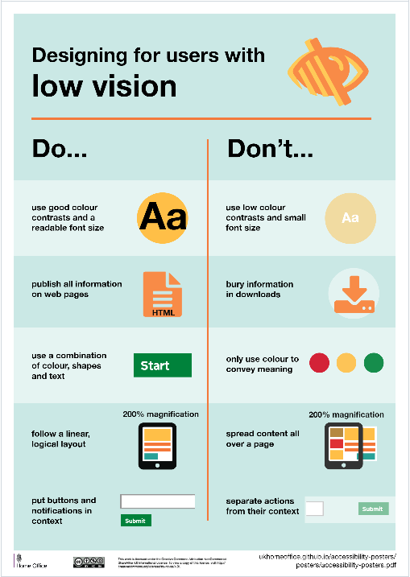
Figure 14: Dos and Don'ts posters

A screen reader is a software application used by blind people to navigate around a computer screen.
Switch access comes in many forms but it is essentially a button or an external device which is used as an alternative to a keyboard and/or mouse.
www.microsoft.com/en-ww/microsoft-365/microsoft-stream

