LetMeType
Contents

LetMeType 2
Getting Started 3
Add words to your list 8
Learn words by Typing 8
Learn Words by reading the clipboard 10
Create a new word list 12
Change the background colour and font of the Suggestions Box 13
Close LetMeType 14

LetMeType

LetMeType is a word prediction programme that predicts single words or phrases in a range of applications.
Who would benefit?
LetMeType benefits individuals who require additional help with spelling and/or word recognition, particularly with longer complex words. LetMeType will also benefit individuals who have a mobility difficulty and find it difficult to input text or are slow typists.
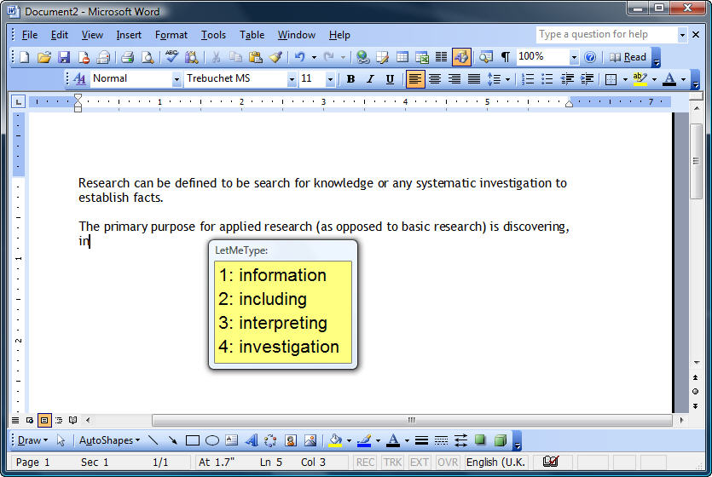

Main Features:
- Predicts in most Windows applications, Microsoft Word, Open Writer etc.
- Predicts words after first two or three letters have been typed.
- Predicts words in context.
- Predicts single words or phrases.
- Customise prediction window with font, font size and colour background.

Getting Started
- Click on the Writing icon on MyStudyBar and select LetMeType.
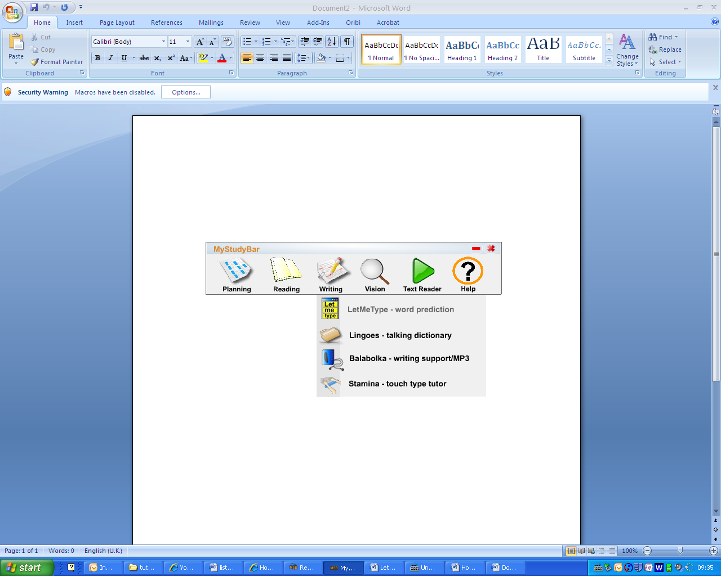
- The LetMeType appear at the bottom right hand corner of your screen, as a pop up box.
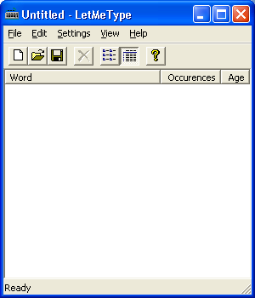
- At the moment there are currently no words available for word prediction. Therefore you will need to open a list of words. Click File > Open
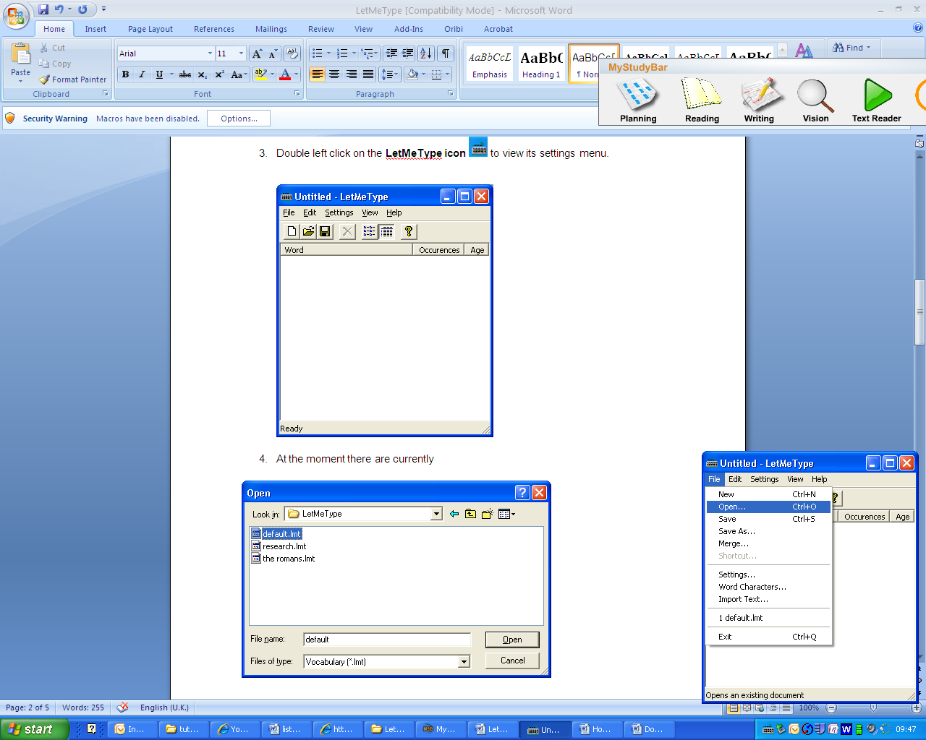
- Browse for the default.lmt word list. This is on your USB memory stick in the MyStudyBar folder. To find this folder click on Look in: dropdown menu and select My Computer.
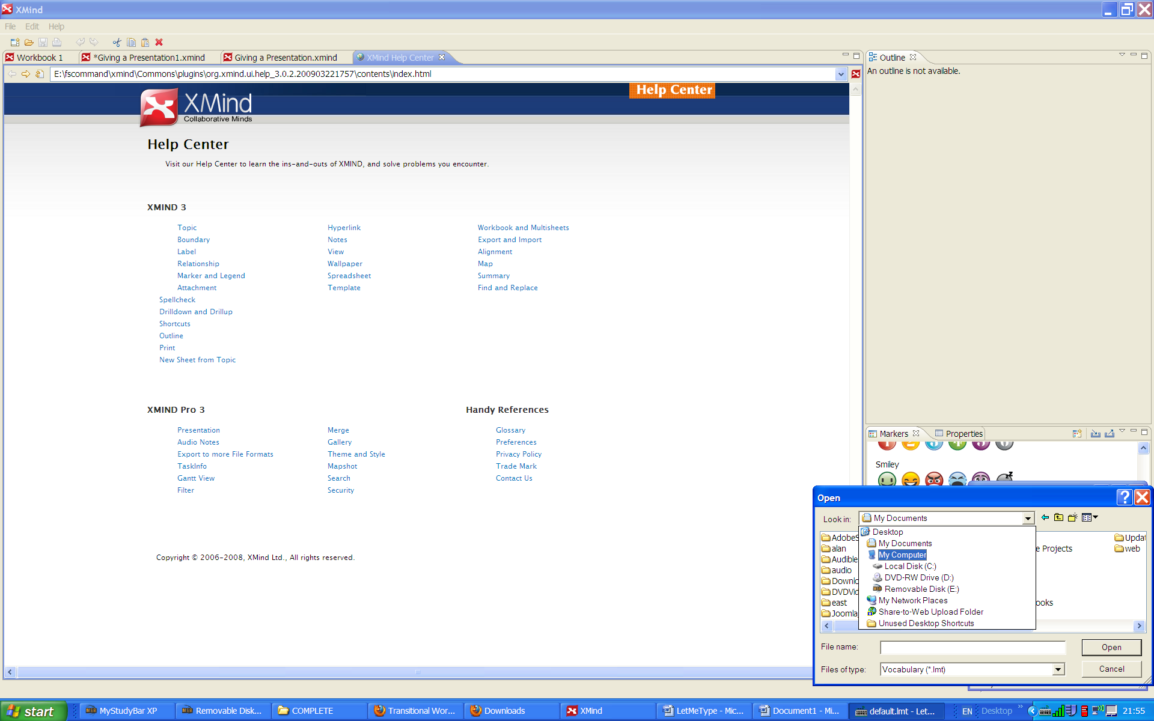
fscommand\LetMeType. The default.lmt file contains a basic list of words (this contains a basic list of words) and click on the Open Button

- Select your pen drive and click Open.

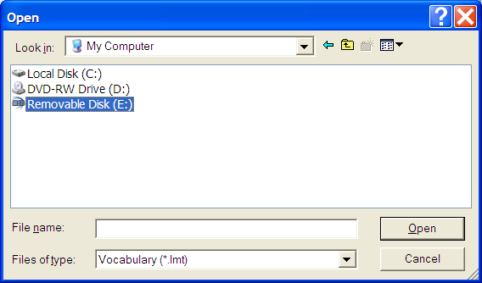

- Double click on the MyStudyBar folder.
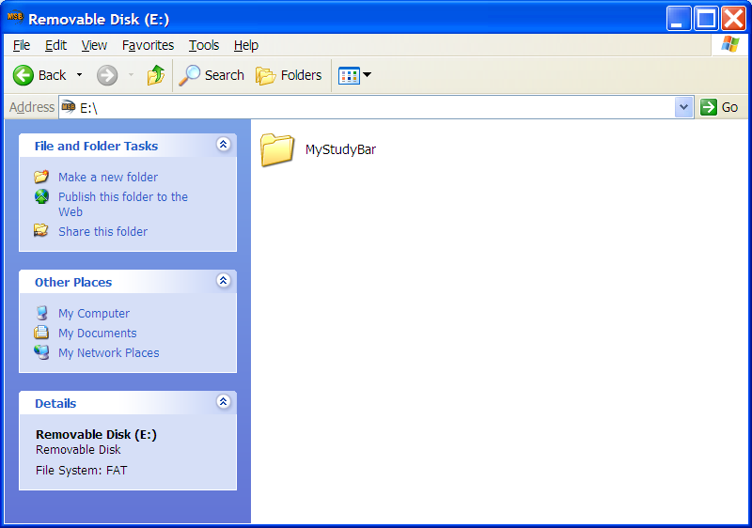

- Select the default.Imt file and click Open.

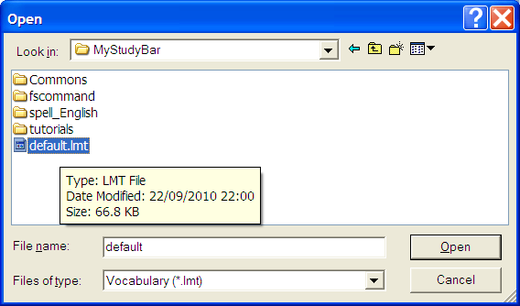

- A list of words will appear in the LetMeType popup box.
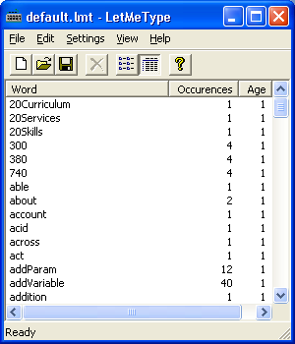

- Minimise the pop up box. (You can open it later by double left clicking on the LetMeType icon 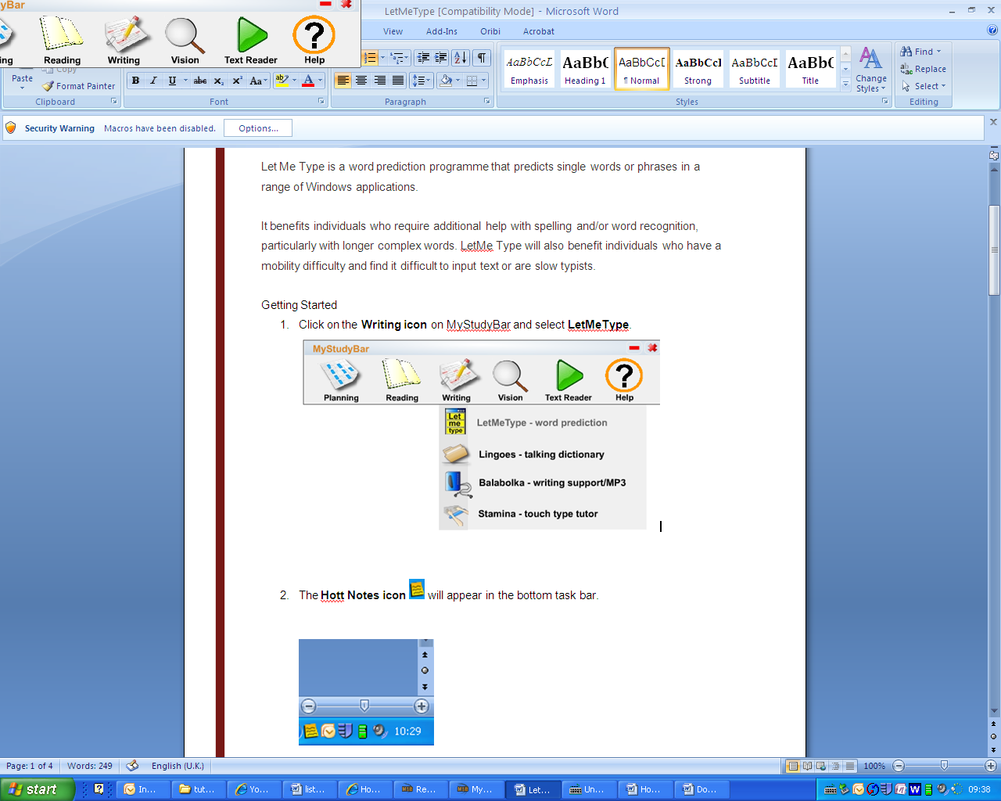 in the bottom task bar.)
- Now that we have opened the word list we can start using it while typing. Right click on the LetMeType icon in the bottom task bar and ensure that the Suggest function has a tick next to it.
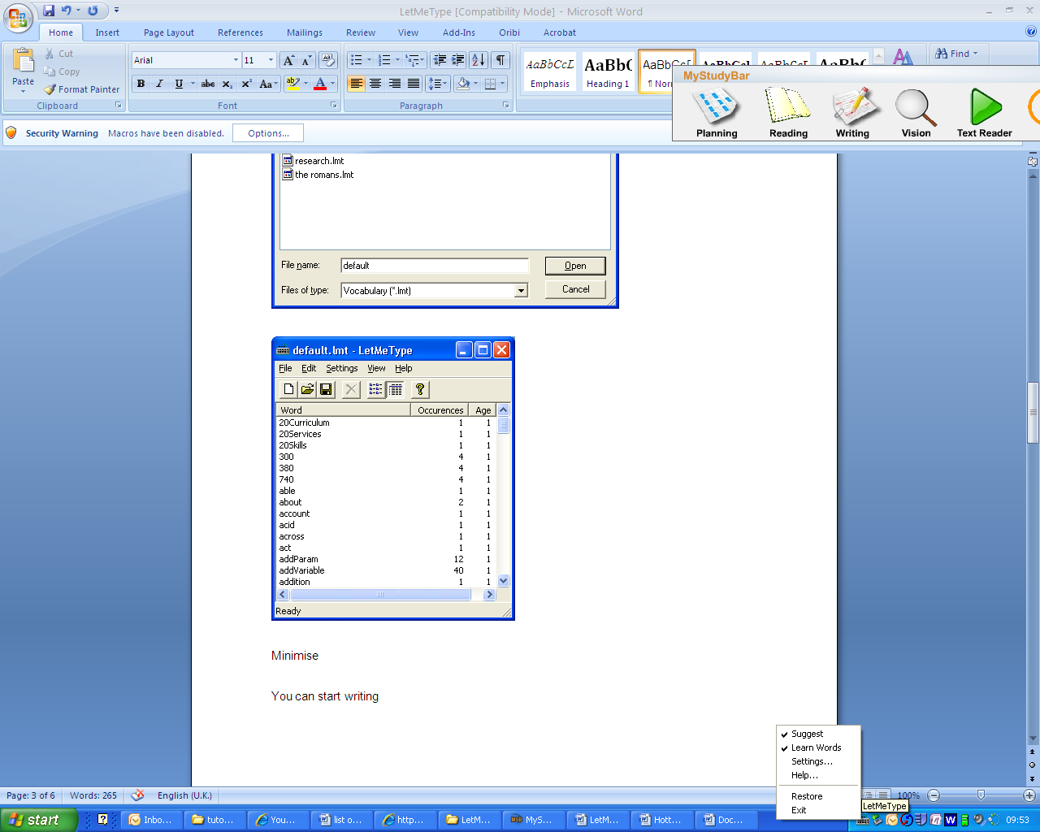
- If the Learn Words function is ticked, the software will learn any new words that you type in. Therefore if you have difficulty with spelling it is best to untick this function, (by clicking on the Learn Words title) as the software will misspell words.
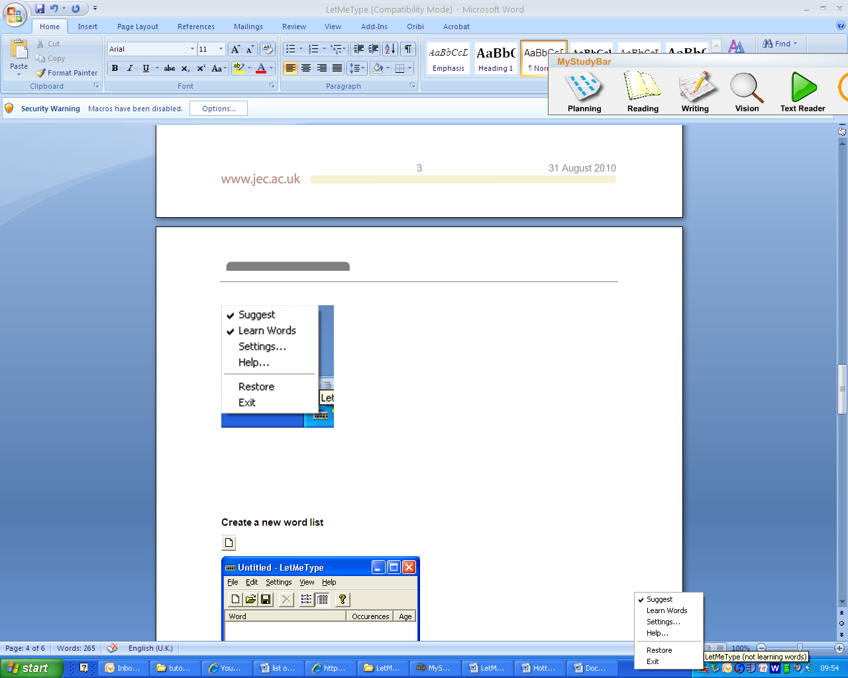

- When you start typing a popup box with suggested words will appear, you can either click on the word you would like or using the number keys select the corresponding number.
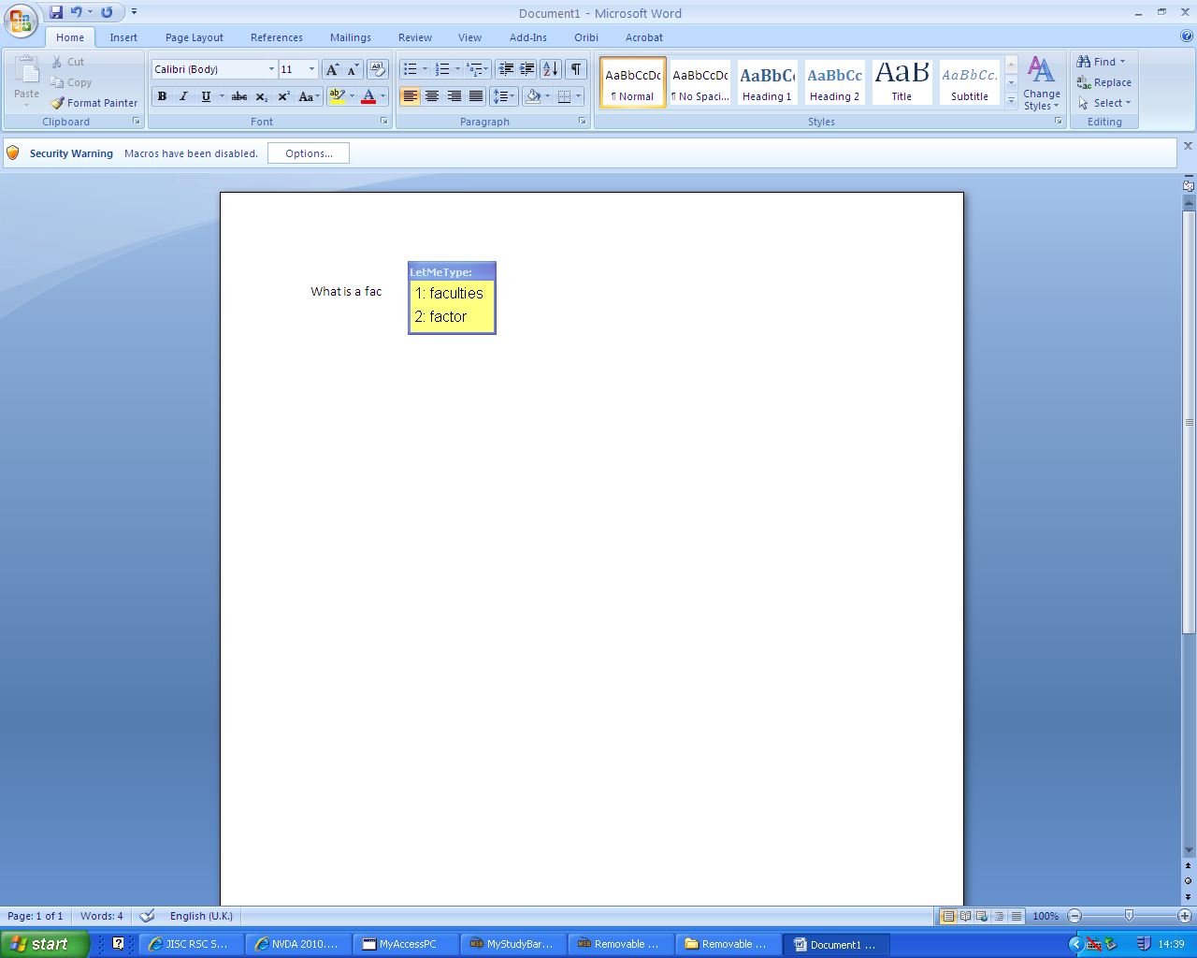

Add words to your list
It is possible to add lists of words to your LetMeType software in two ways: Learn words by Typing and Learn Words by reading the clipboard.

Learn words by Typing

- Right click on the LetMeType icon on the bottom task bar and ensure that the Learn Words function is switched on and has a tick next to it (you can turn it on by clicking on the Learn Words title).

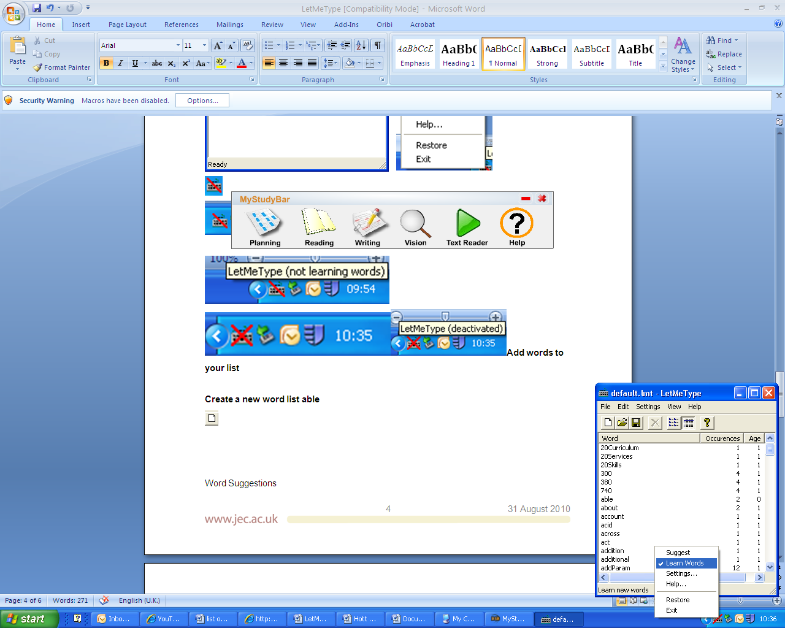
- LetMeType will now learn new words while you type.
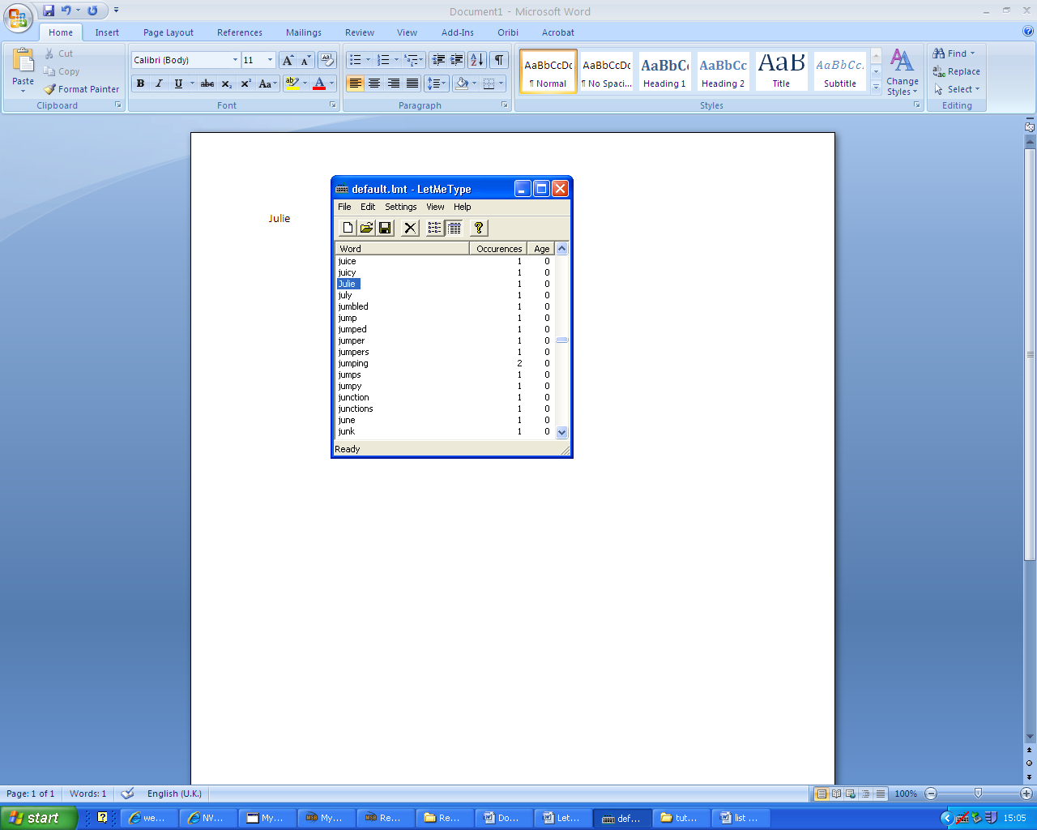

- To save the new words in the list select File and Save.

Note: If you find spelling difficult this is not the best method of adding words to your lists as the software will not correct misspelt words.

Learn Words by reading the clipboard
- Right click on the LetMeType icon on the bottom task bar and ensure that the Learn Words function is switched on and has a tick next to it (you can turn it on by clicking on the Learn Words title).

- Copy a list of words or text, which you have previously created.
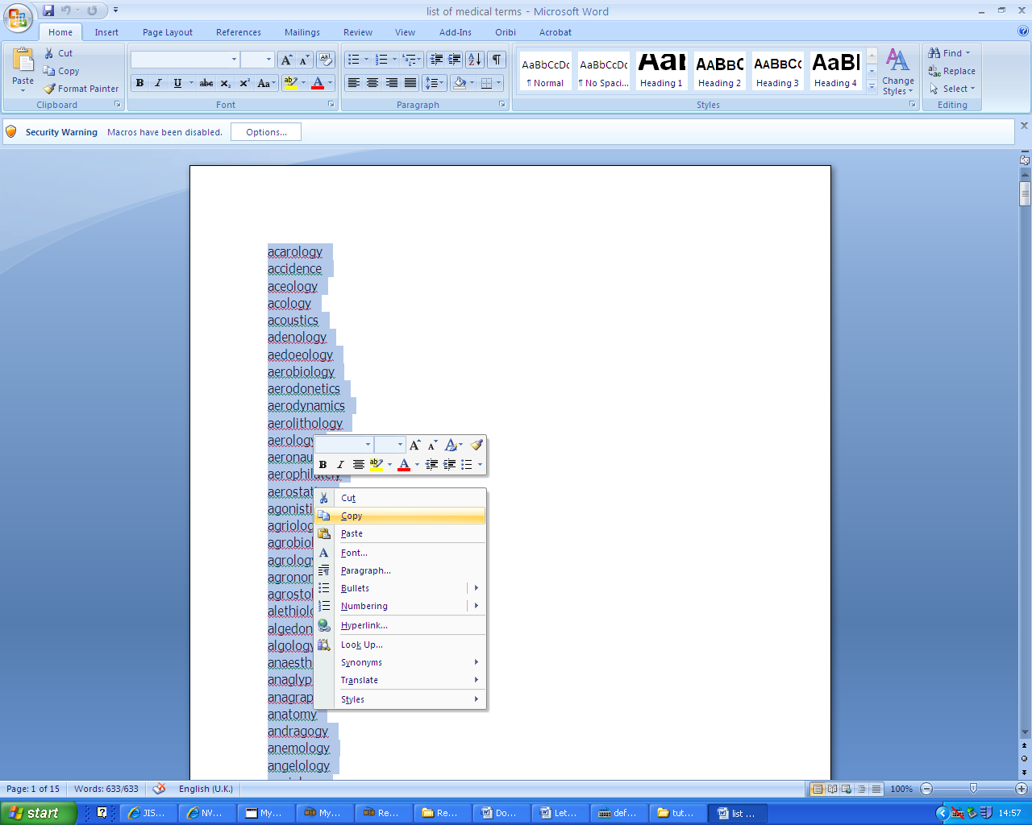

- Double left click on the LetMeType Icon on the bottom task bar. Then select Edit and Read Clipboard.

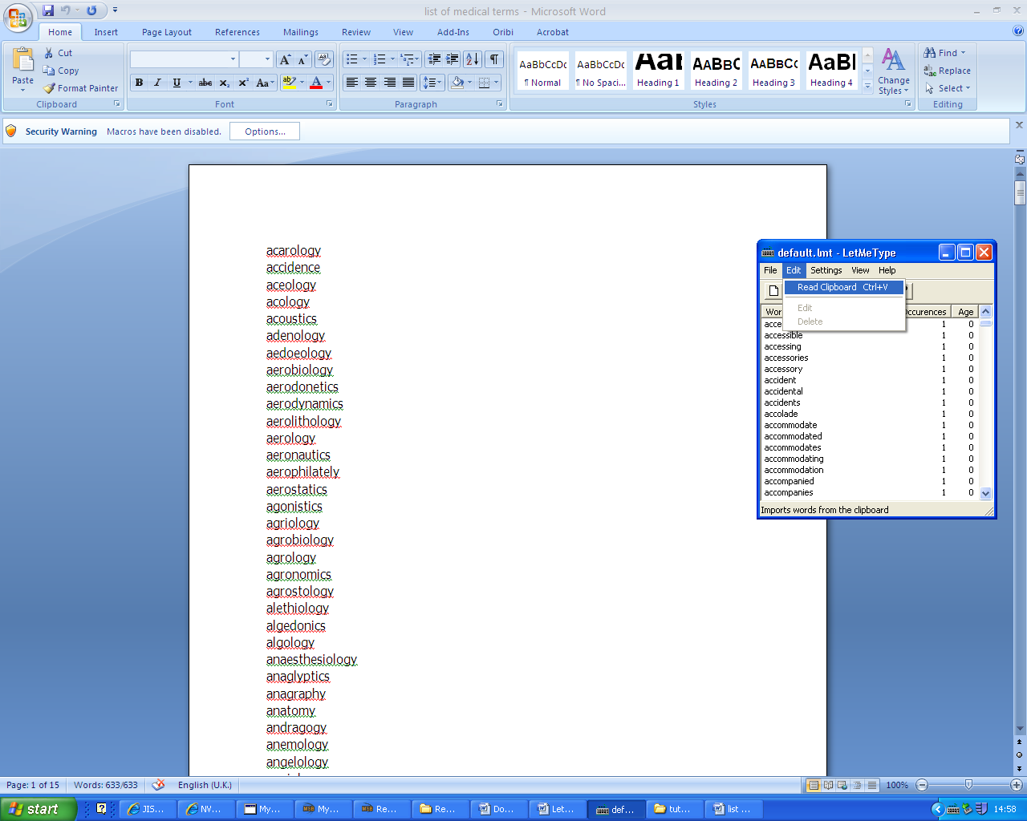

The words will now appear in the current word list.
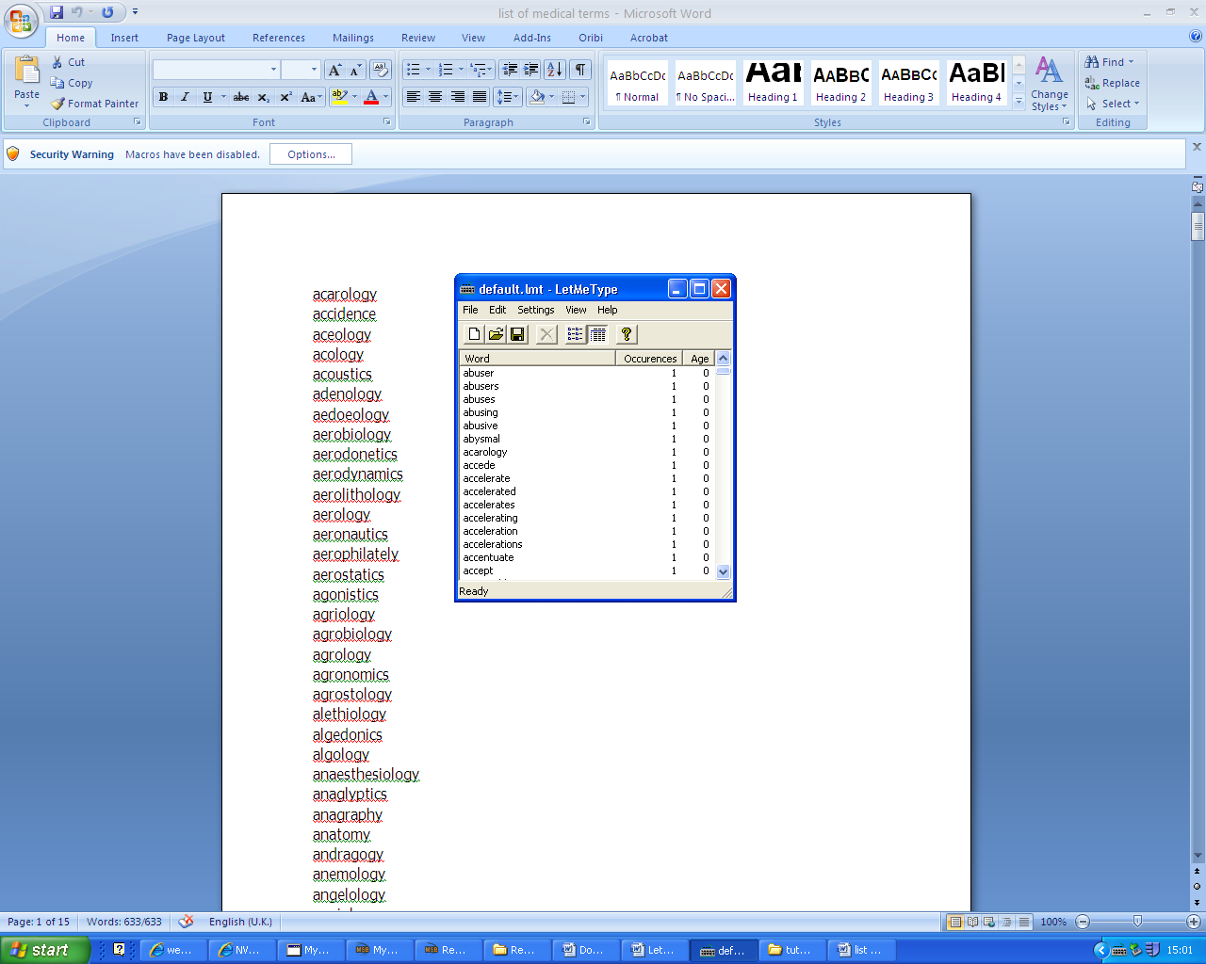

- To save the new words in the list select File and Save.

Create a new word list
- It is possible to create a new word list for a specific topic or essay. To do this double left click on the LetMeType Icon on the task bar.
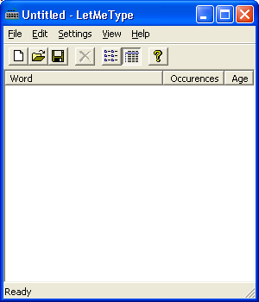
- Select File > New this will create a clear word list, that you can add words to by Typing or reading the clipboard.

Change the background colour and font of the Suggestions Box

- Double left click on the LetMeType Icon on the task bar.
- Select Settings and then select Background colour or Font...
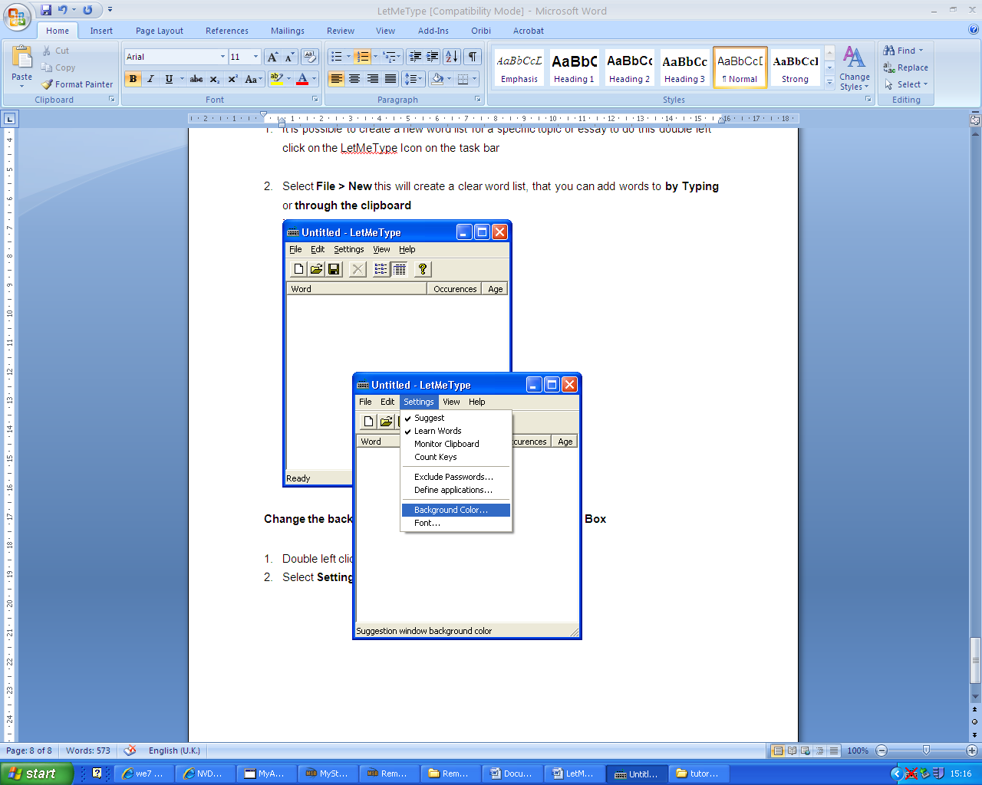
- Select the colour you would like as a background or font, and then click OK.
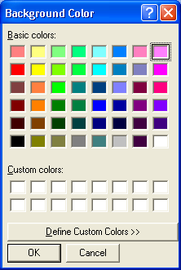
- The next time that you start typing the suggestions box will appear in the colours you have selected.
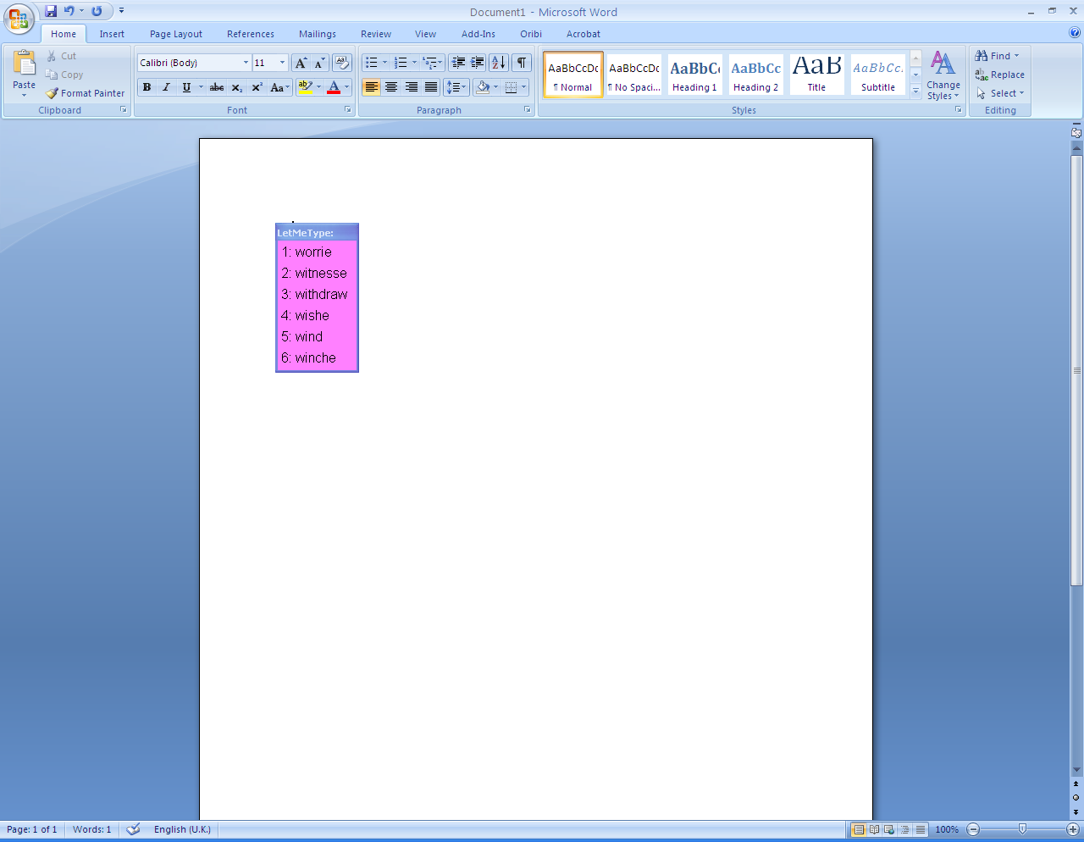

Close LetMeType

- To close the LetMeType application, right click on the LetMeType Icon to view its settings menu. Then select Exit.

