Microsoft Dictate

Windows has three speech to text systems:

Dictate in Microsoft 365
This is the Dictate button in Word and OneNote Online and the Word, Outlook and PowerPoint 365 desktop apps. You need an Office 365 subscription and an internet connection because the speech recognition is done by a Microsoft server. (Dictate is not available in Word Online on an iPad – either through Safari or the Edge browser apps.)

Dictate in Windows 10
Dictate is also built into Windows 10 and can be used to dictate into any application. It works online and so it needs an internet connection. To use it, click into a text window and press Win+H.

Windows Speech Recognition
Windows Speech Recognition is built into Windows on your PC and doesn’t require internet; it lets you control the PC as well as dictate text; you have to train it to get good results ; it’s older technology and the accuracy is not as good as Dictate.

This quick guide covers Dictate in Office 365.

Dictate in Microsoft 365
Microsoft video: How to use Dictation in Microsoft Word for the web.
CALL Scotland video: Using 'Dictate' to dictate text in Word
- Sign in to your Microsoft account – Dictate is only available when you have an Office 365 account. Also we believe it adjusts to how you speak, so you want to use your own account, not someone else’s.
- Go to Home > Dictate and click the button. You may be prompted to enable access to the microphone.
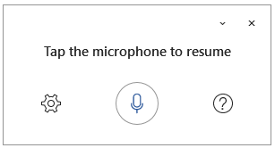
- Click the cog and check it’s set to your language.
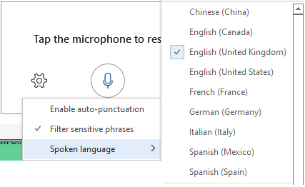
- Dictate your text. Add punctuation by voice (see below).
- Click the mic button or press ALT+` (top left key on the keyboard) to turn it on and off.
- Read back your text and correct errors (see below).
- Close Dictate with the X in the Dictate panel or the button in the Toolbar.

Do I need a special microphone?
It depends on your device and the environment. Most modern laptops, tablets and mobile phones have good microphones which should work well with Dictate. You may get better results with a microphone headset because the volume level should be more consistent. If the enviroment is noisy, a separate noise-cancelling microphone might give you better accuracy. A separate microphone may also enable you to speak more quietly, because the mic is closer to your mouth, which could be important in a classroom or shared office.

How do I correct mistakes?
If Dictate is not sure about a word, it underlines it in grey: click on the word. If it’s correct, choose Ignore. If Dictate has typed the wrong word and it’s in the list offered, choose the correct word. If the correct word is not in the list, re-type it or try dictating it again.
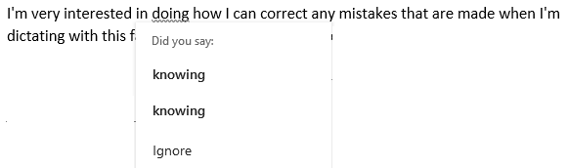
Sometimes, dictate will make a mistake and won't offer you the grey squiggly line. In this case, select the word or phrase and either type it or dictate it again.
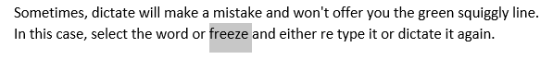

What do I do if Dictate keeps getting a word wrong?
If dictate consistently mis-recognises a word????? Re-type it?

Can I add specific words to the Dictate vocabulary?
No, we don’t think so.

Can I play back a recording of what I dictated?
Not in the desktop Office 365 apps. With 365 Online, you can use the Dictate Transcribe tool to record your dictation, play it back, and then transcribe it to text.

Can I use text-to-speech to read back the dictated text?
Yes, you can use any TTS tool to read the dictated text. Use a headset mic or earbuds/phones to avoid the TTS being picked up by the microphone!
For example, to check a sentence or paragraph of dictation:
- put the cursor where you want to start reading and use Immersive Reader > Read Aloud or press CTRL+ALT+space;
- select the text and click the Speak button to hear it;
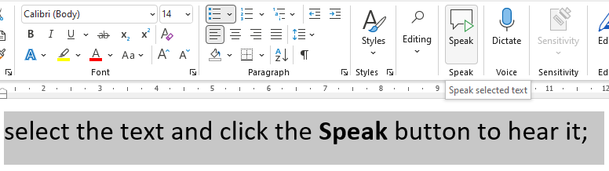
- or use another text-to-speech tool.

Can I use Dictate to control the PC?
No, it’s for dictation only.

Can I use Dictate for SQA Digital Question Papers?
No, you can’t use Dictate to type into PDFs - it only works with Office 365.

Auto-punctuation
You can turn on auto-punctuation in the settings. It adds commas and full stops when you pause. We don’t tend to recommend it for people who’re new to dictation because most people tend to pause when they’re thinking what to say next, and you’ll find Dictate inserts full stops where you don’t want them.

Troubleshooting
This is taken from the Dictate Help guide.

Can't find the dictate button
If you can't see the button to start dictation:
- Make sure you're signed in with an active Microsoft 365 subscription.
- Dictate is not available in Office 2016 or 2019 for Windows without Microsoft 365.
- Make sure you have Windows 10 or above.

Dictate button is grayed out
If you see the dictate button is grayed out:
- Make sure the document is not in a Read-Only state

Microphone doesn't have access
If you see "We don’t have access to your microphone":
- Make sure no other application or web page is using the microphone and try again.
- Refresh, click on Dictate, and give permission for the browser to access the microphone.

Microphone isn't working
If you see "There is a problem with your microphone" or "We can’t detect your microphone":
- Make sure the microphone is plugged in.
- Test the microphone to make sure it's working.
- Check the microphone settings in Control Panel.
- Also see How to set up and test microphones in Windows 10.
- On a Surface running Windows 10: Adjust microphone settings.

Dictation can't hear you
If you see "Dictation can't hear you" or if nothing appears on the screen as you dictate:
- Make sure your microphone is not muted.
- Adjust the input level of your microphone.
- Move to a quieter location.
- If using a built-in mic, consider trying again with a headset or external mic.

Accuracy issues or missed words
If you see a lot of incorrect words being output or missed words:
- Make sure you're on a fast and reliable internet connection.
- Avoid or eliminate background noise that may interfere with your voice.
- Try speaking more deliberately.
- Check to see if the microphone you are using needs to be upgraded.

Dictate Voice Commands

Punctuation and symbols
Say | Output
Full stop | .
Comma | ,
Question mark | ?
Exclamation Mark | !
New line | New line
New Paragraph | New line (Enter)
Apostrophe S | ‘s
Colon | :
Semicolon | ;
Open, close quotes | “ “
Hyphen | -
Ellipsis  dot dot dot | …
Underscore | __
M-dash | —
N-dash | –
Begin/open single quote  end/close single quote | ‘ ‘
Backtick | `
Left/ open parentheses; right / close parentheses | ( )
Left / open bracket  right / Close bracket | [ ]
Left / open brace  right /close brace | { }
Asterisk | *
Backslash | \
Forward slash | /
Vertical bar sign Pipe character | |
Paragraph sign
Paragraph mark | ¶
Section sign | §
Ampersand  and sign | &
At sign | @
Copyright sign | ©
Registered sign | ®
Caret symbol | ^

Mathematics
Say | Output
Degree sign | °
Percent sign | %
Number sign | #
Pound sign | £
Plus sign | +
Minus Sign | -
Multiplication sign | x
Plus or minus sign | ±
Division sign | ÷
Equal sign | =
Less than sign  Left angle bracket | <
Greater than sign  Right angle bracket | >
Dollar sign | $
Pound sterling sign | £
Euro sign | €
Yen sign | ¥
Smiley face | : - )
Frowny face | : - (
Winky face | ; - )
Heart emoji | <3

Editing
Say | Output
Undo | Cancels the last operation
Delete | deletes the last word, punctuation or symbol at the cursor
the cursor.
Delete that | deletes the last spoken phrase
Delete last n words | deletes the last n words back from the current cursor.
Delete last n sentences | Deletes the last n sentences back from the current cursor.
Delete " " (word or phrase) | Deletes the spoken word or phrase from recently spoken text.
Insert Space | Insert a space
Backspace | Deletes last word
Backspace n | Deletes the last n characters.

Formatting
Say | Output
Bold
Italics
Underline
Strikethrough
<format*> [word or phrase]
Superscript
Subscript
Indent
Decrease Indent
Clear all formatting
Align Left
Align Right
Align Center / Centre

Lists
Say | Output
Start Numbered List | commence a numbered list.
Next Line | Add a new point / number to the list.
Exit List | Return to normal, non-list text.

Comments
Say | Output
Add Comment | Inserts a comment at the cursor, ready for typing
Add Comment .... | Inserts a comment with the words spoken immediately after the two command words.
Show Help | Display help pane open at Dictation items
Pause Dictation | Pauses dictation / microphone.
Exit Dictation | Same as clicking the microphone icon.

Communication, Access, Literacy and Learning
The Moray House School of Education and Sport
The University of Edinburgh
Paterson's Land, Holyrood Road
Edinburgh EH8 8AQ

Find out more from:
www.callscotland.org.uk

Sign up:
https://www.facebook.com/CALLScotland1983/
https://twitter.com/CALLScotland
https://www.youtube.com/user/callscotland1983
https://www.pinterest.co.uk/callscotland/_created/

