Technology: reading checklist for learners with dyslexia

If you… | learn how to…with… | Windows | ChromeOS | iPad
read very slowly… | use audio books from;  - your local public library which will have an audio book lending service;  - Calibre and Young Calibre Audio Libraries;  - Listening Books;  - or commercial audiobook providers.  change text appearance:  - font;  - font size  - line spacing  - letter spacing  - text colour  - background colour.  - change text and page colours  - use an on-screen line focus or reading ruler  - use text-to-speech  - use a Reader Pen; trials are available from ScanningPens.  - take a photo of the page and read text with text-to-speech  - ask your teachers to scan paper resources into a readable, digital format. | Change text appearance and colours with Immersive Reader in Edge and Office 365.  Change text appearance in Word.  Use Line Focus in Immersive Reader.  Read Aloud, Speak or Immersive Reader in Edge, Word and OneNote.  OneNote to copy text and read. | Change text appearance and colours with Immersive Reader extension in Chrome and Office 365 online.  Change text appearance in Docs.  Use Line Focus in Immersive Reader.  Select to Speak in Google Docs.  Google Lens or Microsoft Lens app. | Change text appearance and colours with Safari Reader or Immersive Reader in Edge and Office 365.  Change text appearance in your word processor.  Use Line Focus in Immersive Reader.  iPad Speak Selection and typing feedback.  Live Text in Photos or Seeing AI.
find reading difficult and tiring… | use audio books from;  - your local public library which will have an audiobook lending service  - Calibre and Young Calibre Audio Libraries  - Listening Books  - or commercial audiobook providers.  change text appearance:  - font  - font size  - line spacing  - letter spacing  - text colour  - background colour.  - change text and page colours  - use an on-screen line focus or reading ruler  - use text-to-speech  - use a Reader Pen; trials are available from ScanningPens.  - take a photo of the page and read text with text-to-speech  - ask your teachers to scan paper resources into a readable, digital format. | Change text appearance and colours with Immersive Reader in Edge and Office 365.  Change text appearance in Word.  Use Line Focus in Immersive Reader.  Read Aloud, Speak or Immersive Reader in Edge, Word and OneNote.  OneNote to copy text and read. | Change text appearance and colours with Immersive Reader extension in Chrome and Office 365 online.  Change text appearance in Docs.  Use Line Focus in Immersive Reader.  Select to Speak in Google Docs.  Google Lens or Microsoft Lens app. | Change text appearance and colours with Safari Reader or Immersive Reader in Edge and Office 365.  Change text appearance in your word processor.  Use Line Focus in Immersive Reader.  iPad Speak Selection and typing feedback.  Live Text in Photos or Seeing AI.
misread or misinterpret text… | - use the tools and strategies above  - look up word definitions or information  - use a Picture Dictionary, e.g. in Immersive Reader. | Thesaurus  Voice search in Edge. | Docs Explore.  Voice search in Google. | Look up words  Siri
have to read text over again to make sense… | - see above  - use highlighter, annotations and comments to mark key sections  - use comments or audio notes to add notes as you read. | Word highlight and comments. | Docs highlight and comments. | Pages highlight and comments.
have difficulty finding information in a text… | - see above  - use highlighter to mark key sections  - use comments or audio notes to add notes as you read. | Word highlight and comments. | Docs highlight and comments. | Pages highlight and comments.
lose your place when you are copying from the white/black board… | - ask your teacher for digital notes before the lesson  - take photos of the board with your device and add notes as you go. | OneNote to copy text and read. | Google Lens or Microsoft Lens app | Live Text in Photos or Seeing AI.
lose the place when reading… | - use text-to-speech with words / sentences highlighted  - use a reading ruler / line focus. | Immersive Reader in Edge, Word or OneNote. | Select to Speak in Google Docs. | iPad Speak Selection and typing feedback.
forget the beginning in longer questions… | - ask your teacher to give you a step-by-step breakdown (for verbal questions)  - Ask your teacher for a digital learning resource so that you can re-read when you want. | See above | See above | See above
find it hard to use a dictionary or index… | - use a digital dictionary  - use a digital book with clickable contents and index  - use voice to search a digital or online dictionary. | Microsoft Editor  Thesaurus  Voice search in Edge | Google Docs spelling and grammar  Voice search in Google. | Pages check spelling  Look up words  Siri
find black print on white paper difficult to see clearly… | - ask your teacher for a digital copy so you can change the text size, font and colours. | See above | See above | See above

Useful Resources
To help support reading, CALL has a range of useful free resources.

A series of short video guides to support writing difficulties and more:
https://bit.ly/iPad-Video-Short-Guides
https://bit.ly/MS-Word-ASN-video-guides

Posters and infographics including CALL’s popular Supporting Reading Difficulties poster.
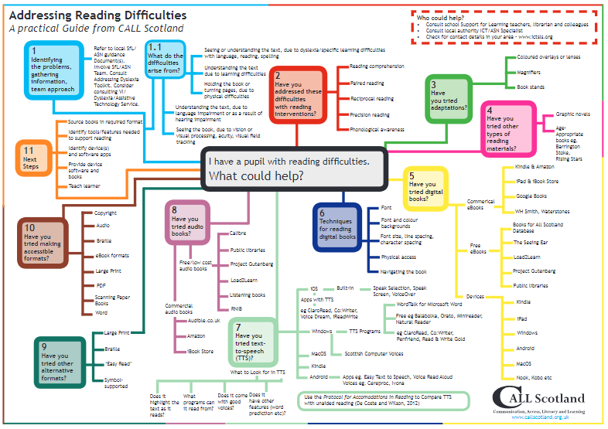
Interesting blog/guides that explore different devices to support writing.
Paul’s articles: www.callscotland.org.uk/blog/author/paul-nisbet/
Craig’s articles: www.callscotland.org.uk/blog/author/craig-mill/
Courses including: free webinars, 1 hour training courses, 5-week courses, 10-week courses and online courses.
www.callscotland.org.uk/training/

