Technology: writing checklist for learners with dyslexia

If you… | learn how to… with… | Windows | ChromeOS | iPad
want to organise ideas on paper compared to explaining… | - think and plan with mind maps.  - outline and sort your ideas with slide decks.  - record your ideas with voice notes or video.  - combine all of the above. | Digital mind maps  PowerPoint  OneNote  Record with PowerPoint | Digital mind maps  Google Slides  OneNote  Record with PowerPoint Online | Digital mind maps  Keynote  OneNote  Keynote
want to listen and take notes at the same time… | - ask your teacher for a digital handout or copies of slides before the lesson.  - record the lesson - audio or video (ask permission first). | Teams  OneNote record audio and video | Google Classroom  OneNote record audio and video | Teams  OneNote record audio and video
want to copy accurately at the same speed as others… | - ask your teacher for a digital handout or copies of slides before the lesson.  - practice your typing.  - consider a different type of keyboard.  - dictate with speech-to-text.  - record your notes orally. | Teams  Doorway Text Type / BBC Dance Mat  Dictate in Office 365  Windows Voice typing (Windows 10/11)  OneNote record audio and video | Google Classroom  Doorway Text Type / BBC Dance Mat  Google Voice Typing  Chrome speech to text  OneNote record audio and video | Teams  Doorway Text Type / BBC Dance Mat  iOS Dictation  iOS Voice Control  OneNote record audio and video
want to find the exact word you want to use… | - read back your writing with text-to-speech.  - use a thesaurus or look-up.  - ask the internet for a good word. | Read Aloud, Speak or Immersive Reader in Word or OneNote.  Thesaurus  Voice search in Edge. | Select to Speak in Google Docs.  Docs Explore.  Voice search in Google. | iPad Speak Selection and typing feedback.  Look up words  Siri
miss out or add in letters or words,  or miss out little words… | - read back your writing with text-to-speech.  - check your writing with the spellchecker and grammar checker. | Read Aloud, Speak or Immersive Reader in Word or OneNote.  Microsoft Editor | Select to Speak in Google Docs.  Google Docs spelling and grammar | iPad Speak Selection and typing feedback.  Pages check spelling
confuse or reverse letters in a word e.g. b/d; b/p; f/t; n/v… | - type with a good font, in a large text size and with wide line spacing.  - read back your writing with text-to-speech.  - use a spellchecker or autocorrect. | Read Aloud, Speak or Immersive Reader in Word or OneNote.  Microsoft Editor | Select to Speak in Google Docs.  Google Docs spelling and grammar | iPad Speak Selection and typing feedback.  Pages check spelling
want to write essays/reports in the right order… | - think and plan with mind-maps.  - outline and sort your ideas with slides.  - record your ideas with voice notes. | Digital mind maps  PowerPoint  OneNote  Record with PowerPoint | Digital mind maps  Google Slides  OneNote  Record with PowerPoint Online | Digital mind maps  Keynote  OneNote  Keynote
want to improve your writing… | - use technology to write. | Windows laptop or table | Chromebook | iPad
want to improve your spelling… | - read back your writing with text-to-speech.  - use spellchecker and autocorrect.  - use a grammar checker.  - use word prediction.  - dictate with speech-to-text. | Read Aloud, Speak or Immersive Reader in Word or OneNote.  Office Spellcheck.  Microsoft Editor  Grammarly  Dictate in Office 365  Windows Voice typing (Windows 10/11 | Select to Speak in Google Docs.  Google Docs spelling and grammar  Grammarly  Google Voice Typing  Chrome speech to text | iPad Speak Selection and typing feedback.  Pages check spelling  Grammarly  iOS Dictation  iOS Voice Control

Useful Resources
To help support writing, CALL has a range of useful free resources.

A series of short video guides to support writing difficulties and more:
https://bit.ly/iPad-Video-Short-Guides
https://bit.ly/MS-Word-ASN-video-guides

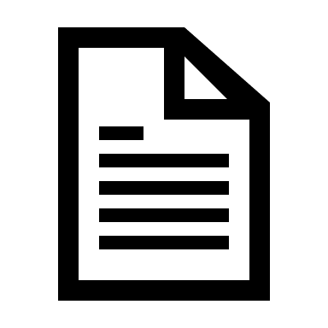 | 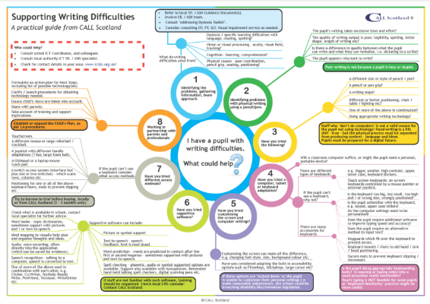  Posters and infographics including CALL’s popular Supporting Writing Difficulties poster.
Interesting blog/guides that explore different devices to support writing.
Paul’s articles: www.callscotland.org.uk/blog/author/paul-nisbet/
Craig’s articles: www.callscotland.org.uk/blog/author/craig-mill/
Courses including: free webinars, 1 hour training courses, 5-week courses, 10-week courses and online courses.
www.callscotland.org.uk/training/

