Technology Checklist for learners with dyslexia - Windows

This resource is designed to help pupils and staff identify and explore technology to help address specific needs arising from dyslexia.

We have taken each of the challenges listed in the Pupil Checklist for Dyslexia on the Addressing Dyslexia Toolkit and suggested some strategies and tools to explore and evaluate.

The tools are mostly freely available or can be accessed via your Glow log-in, so everyone in a Scottish state school should be able to access them. They may or may not be the best tools to meet your own needs but we hope that this will help you to get started with technology to do things that you currently find hard.

This version is for learners who use laptops and devices running Windows 10 or 11: we are developing versions for iPads and Chromebooks.

If you are reading this in Microsoft Word 365 or Word Online, why not try using Immersive Reader as you go through it so you can try out some of the tools? Go to View and click or tap Immersive Reader.

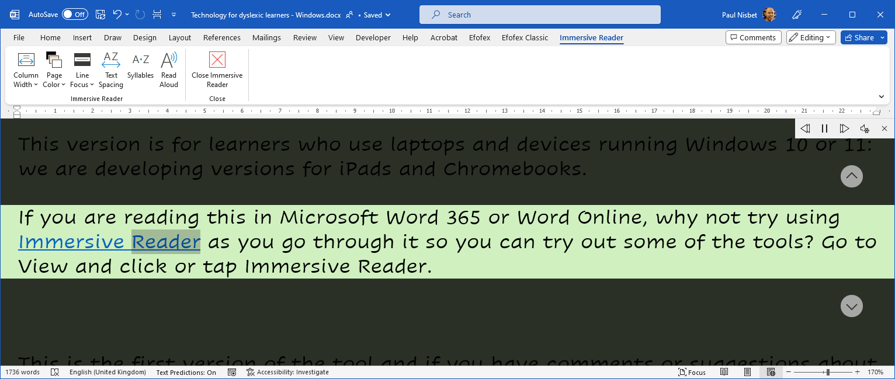

This is the first version of the tool and if you have comments or suggestions about how it could be improved, please do let me know by emailing Paul.Nisbet@ed.ac.uk.

Writing
If you… | learn how to… | With…
find it hard to organise ideas on paper compared to explaining | - think and plan with mind-maps.  - outline and sort your ideas with slide decks.  - record your ideas with voice notes or video.  - combine all of the above. | - Digital mind maps  - PowerPoint  - Record with OneNote  - Record with Powerpoint
find it hard to listen and take notes at the same time | - ask your teacher for a digital handout or copies of slides before the lesson.  - record the lesson - audio or video (ask permission first). | - Teams  - OneNote record audio and video
have difficulty copying accurately at the same speed as others | - ask your teacher for a digital handout or copies of slides before the lesson.  - practice your typing.  - consider a different type of keyboard.  - dictate with speech-to-text.  - record your notes orally. | - Teams and/or OneNote.  - Doorway Text Type / BBC Dance Mat  - Dictate in Office 365  - Windows Voice typing  - OneNote record audio and video
have problems finding the exact word you want to use | - read back your writing with text-to-speech.  - use a thesaurus or look-up.  - ask the internet for a good word. | - Read Aloud, Speak or Immersive Reader in Word or OneNote.  - Thesaurus  - Voice search in Edge or Chrome.
miss out or add in letters or words,  or miss out little words | - read back your writing with text-to-speech.  - check your writing with the spellchecker and grammar checker. | - Read Aloud, Speak or Immersive Reader in Word or OneNote.  - Microsoft Editor
confuse or reverse letters in a word e.g. b/d; b/p; f/t; n/v | - Choose a more readable font, in a large text size and with wide line spacing.  - read back your writing with text-to-speech.  - use a spellchecker or autocorrect. | - Read Aloud, Speak or Immersive Reader in Word or OneNote.  - Microsoft Editor
have problems writing essays/reports in the right order | - think and plan with mind-maps.  - outline and sort your ideas with slides.  - record your ideas with voice notes. | - Digital mind maps  - PowerPoint  - Record with OneNote  - Record with Powerpoint
have messy or illegible handwriting | - use technology to write. | - Windows laptop or tablet
have difficulties with spelling | - read back your writing with text-to-speech.  - use spellchecker and autocorrect.  - use a grammar checker.  - use word prediction.  - dictate with speech-to-text. | - Read Aloud, Speak or Immersive Reader in Word or OneNote.  - Office Spellcheck.  - Microsoft Editor  - Grammarly  - Dictate in Office 365  - Windows Voice typing

For more ideas look at CALL’s Supporting Writing Difficulties poster.
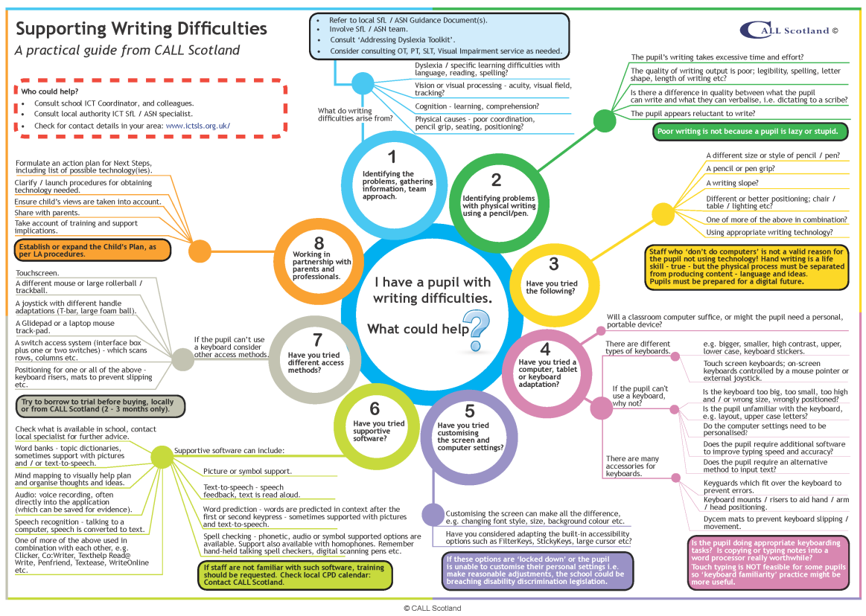

Reading
If you… | learn how to… | with…
read very slowly | - use audio books from e.g.  - your local public library which will have an audio book lending service;  - Calibre and Young Calibre Audio Libraries;  - Listening Books;  - or commercial audio book providers.  - change text appearance:  - font;  - font size;  - line spacing;  - letter spacing;  - text colour;  - background colour.  - change text and page colours.  - use an on-screen line focus or reading ruler.  - use text-to-speech.  - use a Reader Pen; trials are available from ScanningPens.  - take a photo of the page and read text with text-to-speech.  - ask your teachers to scan paper resources into a readable, digital format. | - Immersive Reader in Edge and Office 365 to change text appearance.  - Immersive Reader extension in Chrome browser.  - Word or OneNote, when you are writing.  - Line Focus in Immersive Reader.  - Vu-Bar screen ruler, T-Bar screen masking or ssOverlay in MyStudyBar.  - Read Aloud, Speak or Immersive Reader in Edge, Word and OneNote.  - OneNote to copy text and read.
find reading difficult and tiring | - use audio books from e.g.  - your local public library which will have an audio book lending service;  - Calibre and Young Calibre Audio Libraries;  - Listening Books;  - or commercial audio book providers.  - change text appearance:  - font;  - font size;  - line spacing;  - letter spacing;  - text colour;  - background colour.  - change text and page colours.  - use an on-screen line focus or reading ruler.  - use text-to-speech.  - use a Reader Pen; trials are available from ScanningPens.  - take a photo of the page and read with text-to-speech.  - ask your teachers to scan paper resources into a readable, digital format. | - Immersive Reader in Edge and Office 365 to change text appearance.  - Immersive Reader extension in Chrome browser.  - Word or OneNote, when you are writing.  - Line Focus in Immersive Reader.  - Vu-Bar screen ruler, T-Bar screen masking or ssOverlay in MyStudyBar.  - Read Aloud, Speak or Immersive Reader in Edge, Word and OneNote.  - OneNote to copy text and read.
misread or misinterpret text | - use the tools and strategies above.  - look up word definitions or information.  - use a Picture Dictionary, e.g. in Immersive Reader. | - Thesaurus  - Voice search in Edge or Chrome.  - Immersive Reader Picture Dictionary.
have to read text over again to make sense | - use the tools and strategies above.  - use highlighter, annotations and comments to mark key sections.  - use comments or audio notes to add notes as you read. | - Word highlight and comments.
have difficulty finding information in a text | - use the tools and strategies above.  - use highlighter to mark key sections.  - use comments or audio notes to add notes as you read. | - Word highlight and comments.
lose your place when you are copying from the white/black board | - ask your teacher for digital notes before the lesson.  - snap photos of the board with your mobile into OneNote and add notes as you go. | - 11 ways to rule school with OneNote  - OneNote to copy text and read.
lose the place when reading | - use text-to-speech with words / sentences highlighted.  - use a reading ruler / line focus. | - Read Aloud, Speak or Immersive Reader in Edge, Word and OneNote.
forget the beginning in longer questions | - ask your teacher to give you a step-by-step breakdown (for verbal questions).  - ask your teacher for a digital learning resource so that you can re-read whenever you want. | - Read Aloud, Speak or Immersive Reader in Edge, Word and OneNote.
find it hard to use a dictionary or index | - use a digital dictionary.  - use a digital book with clickable contents and index.  - use voice to search a digital or online dictionary. | - Microsoft Editor  - Thesaurus  - Voice search in Edge or Chrome.
find black print on white paper difficult to see clearly | - ask your teacher for a digital copy so you can change the text size, font and colours. | - Immersive Reader in Edge, Word and OneNote.  - A different page background and text colour in Adobe Reader, for PDFs.

For more ideas look at CALL’s Addressing Reading Difficulties poster.

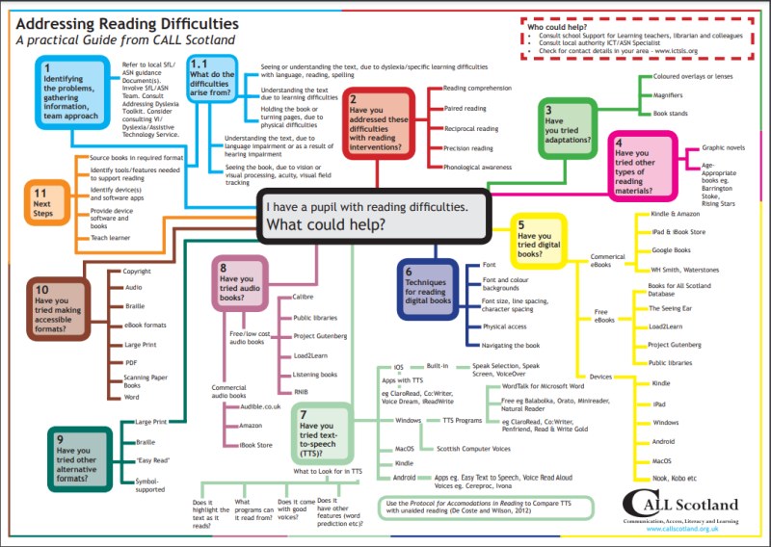

Numbers/Maths
If you… | learn how to… | With…
mix up numbers or confuse maths symbols | - write numbers with a keyboard.  - write expressions with an equation editor.  - read numbers and symbols with text-to-speech. | - CALL Maths grids for column calculations (Word and PDF).  - Microsoft Office Equation Editor  - Read Aloud or Immersive Reader to read the maths symbols.
confuse dates and times | - read dates and times with text-to-speech. | - Read Aloud, Speak or Immersive Reader in Edge, Word and OneNote.
have difficulty with directions (left/right) | - wear a watch or other item on one wrist to remind you which is left and which is right.  - use the navigation app on your mobile.  - Write down or record and play back the steps for your journey in OneNote. | - Google Maps, Apple Maps.  - Record with OneNote
find it hard to remember tables | - practice with games and activities.  - use a times tables grid. | - E.g. www.timestables.co.uk  - E.g. https://www.timestables.co.uk/times-tables-grid/
find it hard to get information from graphs and charts | - use digital graphs and charts and  - zoom in/out;  - change colours;  - highlight;  - read information with text-to-speech;  - add annotations, e.g. straight lines to guide you.  - Use a screen ruler to guide you. | Web and Word files:  - Immersive Reader in Edge and Word.  - Changing the Page Colour in Word (Design > Page Color).  - Read Aloud, Speak or Immersive Reader in Edge, Word and OneNote.  - Word Draw tools to annotate.  PDFs:  - Changing the page and text / art colour in Adobe Reader.  - Adobe Reader Comment Tools.  Screen Ruler:  - Vu-Bar screen ruler, T-Bar screen masking or ssOverlay in MyStudyBar.
have problems holding numbers in your head when calculating | - use a calculator.  - write down the numbers. | - Windows Calculator
get muddled when doing a complicated maths problem | - ask your teacher for a step-by step summary.  - tick off or strike out each step as you complete them.  - use the Math Assistant in OneNote to learn how to solve a problem. | - Teams and/or OneNote.  - Math Assistant in OneNote.
have problems reading and understanding maths words | - ask your teacher for digital resources created and use text-to-speech to read the words.  - use a maths dictionary. | - Read Aloud, Speak or Immersive Reader in Edge, Word and OneNote.  - Jenny Eather’s online maths dictionary.
find it hard to remember the order of steps to solve problems | - ask your teacher for a step-by step summary.  - tick off or strike out each step as you complete them.  - use the Math Assistant in OneNote to learn how to solve a problem. | - Teams and/or OneNote.  - Math Assistant in OneNote.  - Record with OneNote.

For more ideas look at I Have a Numeracy Difficulty and with Maths, What can Help?

Communication, Access, Literacy and Learning
The Moray House School of Education and Sport
The University of Edinburgh
Paterson's Land, Holyrood Road
Edinburgh EH8 8AQ

Find out more from:
www.callscotland.org.uk

Sign up:
https://www.facebook.com/CALLScotland1983/
https://twitter.com/CALLScotland
https://www.youtube.com/user/callscotland1983
https://www.pinterest.co.uk/callscotland/_created/

