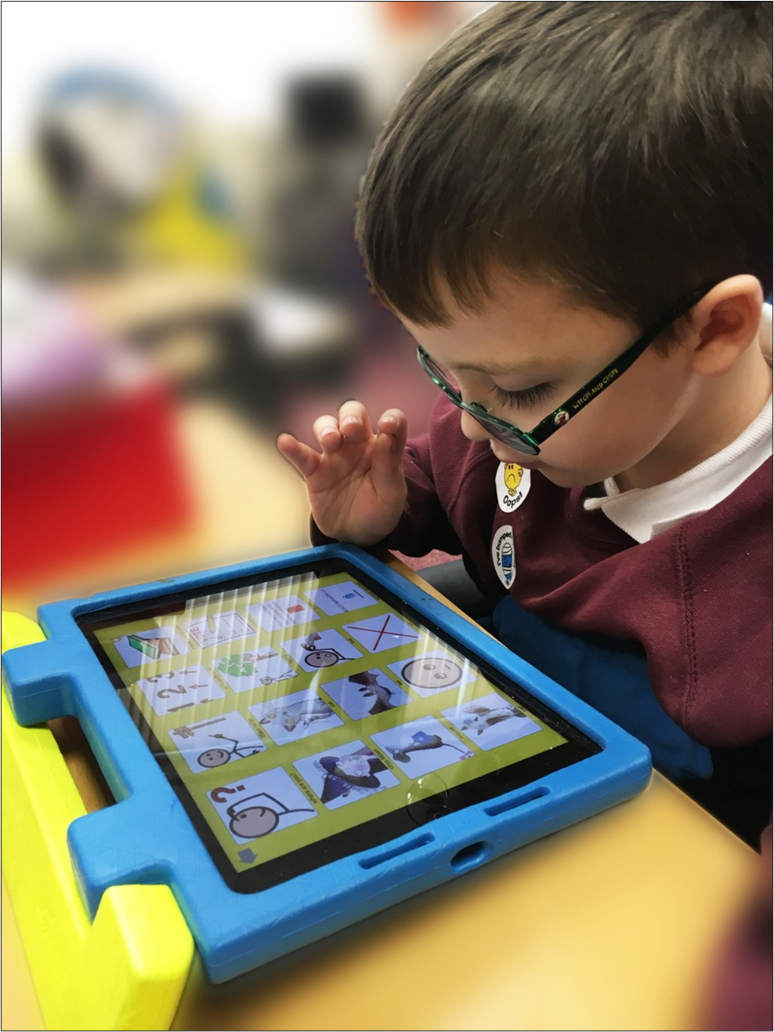

iPad Accessibility Essentials

This paper details free Accessibility tools that should be provided as standard on iPads so that learners with Additional Support Needs and disabilities can access school devices.
By providing these accessibility tools you help to meet Scottish Government recommendations and legal obligations to take reasonable adjustments and provide access under the Equality Act.
The Scottish Government guidance was published in 2014 before iPads were widely used by learners in schools and so this document interprets the guidance for iPad.
Provision of these tools should be planned for and made available when systems are refreshed to meet Scottish Government guidance which states that:

“Computer refreshes or re-imaging are planned to accommodate existing assistive software and hardware used by disabled pupils.”

“Where computer refresh or re-imaging will result in current assistive technology not being usable, replacement or upgrade takes place so that the disabled pupil is not disadvantaged.”

Scottish Government guidance:

“Control Panel settings can be easily and quickly changed to enable access for each disabled pupil, including where needed facility for Right click functionality. Such adjustments can be saved with the user's profile.”

“Staff and pupils are aware of specialist hardware and software installed and Control Panel options on schools computer, to enable access”

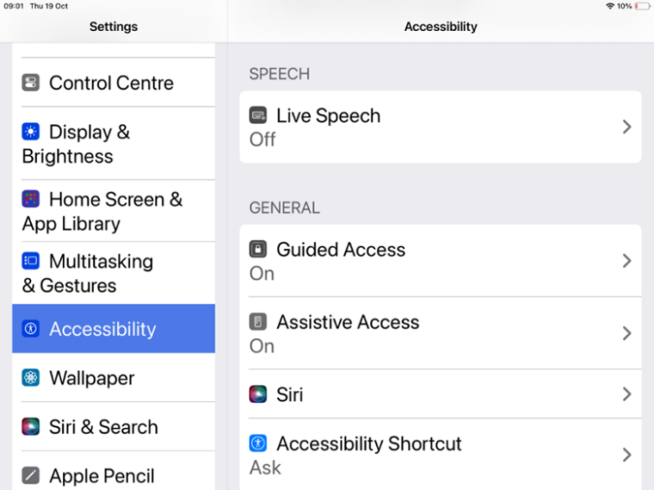

The Scottish Government guidance above was written for Windows 7, and today’s iPads have Accessibility features rather than a Control Panel.
All tools within Accessibility features should be available for learners and staff.
Accessibility features should be available to pupils in the iPad Settings and via the Control Centre or by triple-clicking the Home or Power Buttons.
- Apple Accessibility (YouTube videos)
- iPad short video guides to support reading and writing (Craig Mill’s YouTube playlist)
- Jacob’s Quick Tips (short videos on iPads and iOS)
- Glasgow Teachable Connected Learning (courses on using iPads in school)
- Apple Learning Community (Apple courses and resources)

Recommended Tools | Rationale
Accessibility features are available for learners and staff.  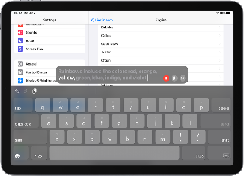  Vision  - Screen tint and invert colours  - Zoom  - Magnifier  - Mouse pointer  - Font size  - VoiceOver screen reader  Mobility  - Voice Control, Siri and dictation  - Predictive text  - iPad on-screen keyboards  - Hardware keyboard, mouse, eye gaze and switch access  - Touch Accommodations and Assistive Touch  Hearing  - Subtitles and captions  - Earpods and hearing aids  Speech  - Text to speech and record your own voice  Cognitive  - Reduce distraction  - Everyday support tools | Learners who require essential adjustments to the iPad can have them.  For example, learners who  - are visually impairment may require larger icons, text, mouse pointer or text cursor or to use the magnifier to zoom in on particular areas of the screen;  - have a reading difficulty can use Speak Selection or Speak Screen to read text;  - are blind may need VoiceOver to read out the screen display and digital text;  - require closed captions should be able to choose an accessible font size;  - cannot use the touch or onscreen keyboard may need an external mouse or pointing device or a hardware keyboard;  - have motor control challenges may need to change touch sensitivity or keyboard settings or use Assistive Touch to control the iPad;  - have difficulty typing may need Siri Dictation.

Learning Tools / Accessibility Shortcuts  - Add Settings to the Home Screen. | Staff and learners are often unaware of learning / accessibility tools and options. Making them clearly available on the iPad makes them more obvious and easier to access.

Scottish Government guidance:

“All school computers have text-to-speech (TTS) software installed for reading documents and web pages.”

Suggested Tools | Rationale
iPad Spoken Content - Speak Selection, Speak Screen and Speech Controller.  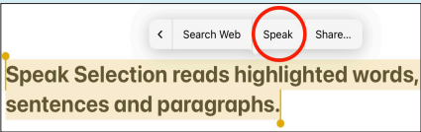  Office 365 Learning Tools  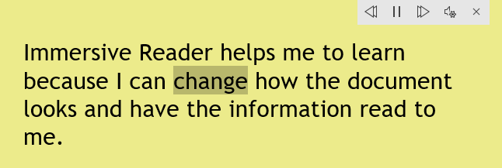 | Learners with dyslexia, literacy challenges, English as an additional language, learning difficulties, visual impairment or hearing impairment can use text-to-speech to access text on the iPad.  If Microsoft 365 is used in school, learners will have access to Immersive Reader and the other Learning Tools in Office 365 online. These are free tools that support reading and comprehension for learners with reading or literacy difficulties, i.e.  - simplified layout;  - colour options;  - line focus;  - Read Aloud text reader;  - Picture Dictionary;  - Dictate.

Scottish Government guidance:

“All school computers accessed by pupils have the free Heather and Stuart voices installed”.

The Scottish Government guidance refers to the free Scottish and Gaelic voices available for Windows and MacOS from CALL Scotland’s Scottish Voice web site.
Heather (adult female) | Andrew (male child)
Stuart (adult male) | Mairi (female child)
Ceitidh (Scottish Gaelic adult female) | Isla (female teenage)
 | Callum (male teenage)

It is not yet technically possible to install the Scottish Voices on iPads although this is in development.
For general use on the iPad, you can download Fiona, a Scottish adult female voice or alternatively you could consider making your own Personal Voice on the iPad.
Grid for iPad, the AAC app, has the Scottish voices, while Proloquo2Go and Proloquo4Text have Archie and Eilidh, Scottish child voices. These voices can only be used in the app.

Recommended Tools | Rationale
- Scottish Fiona voice  - Record a Personal Voice for the iPad | - Learners can read with a high quality Scottish accent.

Scottish Government guidance:

“Specialist software required by learners with disabilities can be easily and quickly installed and used on school computers.”

“Specialist hardware required by learners with disabilities can be easily and quickly installed and used on school computers.”

“Staff (teaching, support, librarian and technical) are made aware of legal obligations to provide access to the curriculum and to curriculum resources under Equality Duties, with particular reference to Guidance on Auxiliary Aids and Services.”

“Procurement decisions for hardware and software have due regard to accessibility and reasonable adjustment duties under the Equality Act. In particular, no extra cost should be charged for changes made to systems as part of reasonable adjustments made.”

Recommended Action | Rationale
Establish an Assistive Technology Pathway so that assistive technologies can be assessed, purchased, installed and supported “quickly and easily”.  Contracts with technology providers should ensure that specialist resources can be made available “quickly and easily” and without incurring additional costs. | Some learners require additional hardware or apps to access digital learning.  The Equality Act requires reasonable adjustments to be made and the need for such adjustments should be anticipated and planned.  The duty applies to services procured from commercial firms as well as those provided in house by local authority technical teams.

Support and information
Apple Accessibility YouTube videos
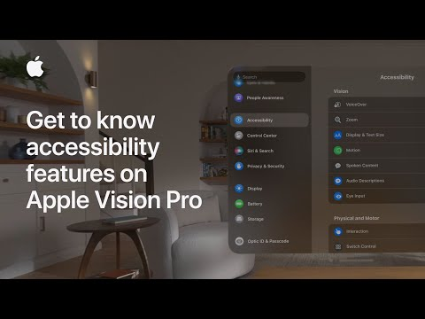
iPad short video guides to support reading and writing (Craig Mill’s YouTube playlist)
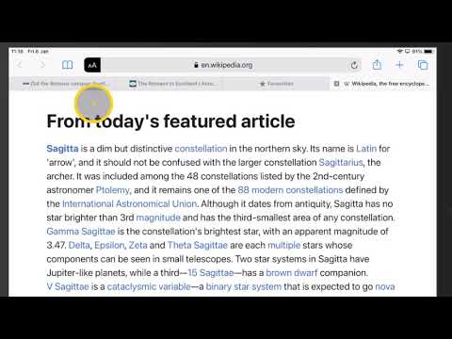
Glasgow Teachable Connected Learning (courses on using iPads in school, including iOS Accessibility)
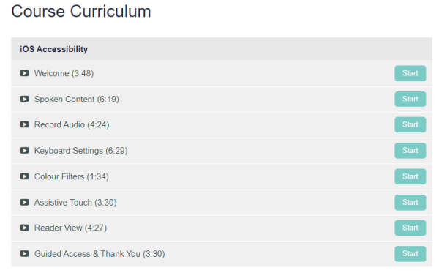

Jacob’s Quick Tips (short videos on iPads and iOS)
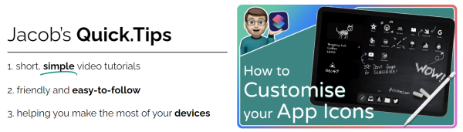
Apple Learning Community (Apple courses and resources including iPad accessibility in the classroom)
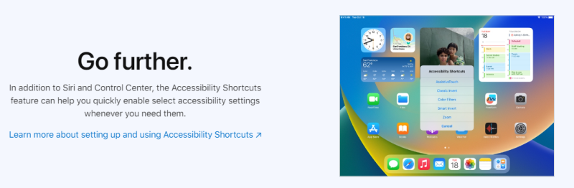

CALL Scotland posters and resources
A complete beginners guide to the iPad
Are you meeting legal requirements for computer accessibility?
iPad Apps for Complex Communication Support needs
iPad Apps for Learners with Complex Additional Support Needs
iPad Apps for Learners with Dyscalculia/Numeracy Difficulties
iPad apps for learners with dyslexia
iPad Apps to Support Creativity
Setting up Guided Access on an iPad
Using the iPad to Support Dyslexia
Using the iPad to Support Learners with Physical Difficulties
Using the iPad to Support Learners with Visual Difficulties

References
Planning improvements for disabled pupils’ access to education: Guidance for education authorities, independent and grant-aided schools, http://www.gov.scot/Publications/2014/10/8011, Appendix D & E.
Reasonable adjustments for disabled pupils - Auxiliary Aids Technical Guidance https://www.equalityhumanrights.com/en/publication-download/reasonable-adjustments-disabled-pupils-scotland
Technical guidance for schools in Scotland https://www.equalityhumanrights.com/en/publication-download/technical-guidance-schools-scotland
Disability Strategies and Pupils' Educational Records (Scotland) (Act) 2002 http://www.legislation.gov.uk/asp/2002/12/pdfs/asp_20020012_en.pdf
Additional Support for Learning - Legislation and Guidance http://www.scotland.gov.uk/Topics/Education/Schools/welfare/ASL

Planning improvements for disabled pupils’ access to education: Guidance for education authorities, independent and grant-aided schools, http://www.gov.scot/Publications/2014/10/8011, Appendix D & E.

